**These are the stories of the people of Burma who received the $50 Alternative Christmas Gift. They total 55 pages.**

**Christmas Gifts Report. 2021**

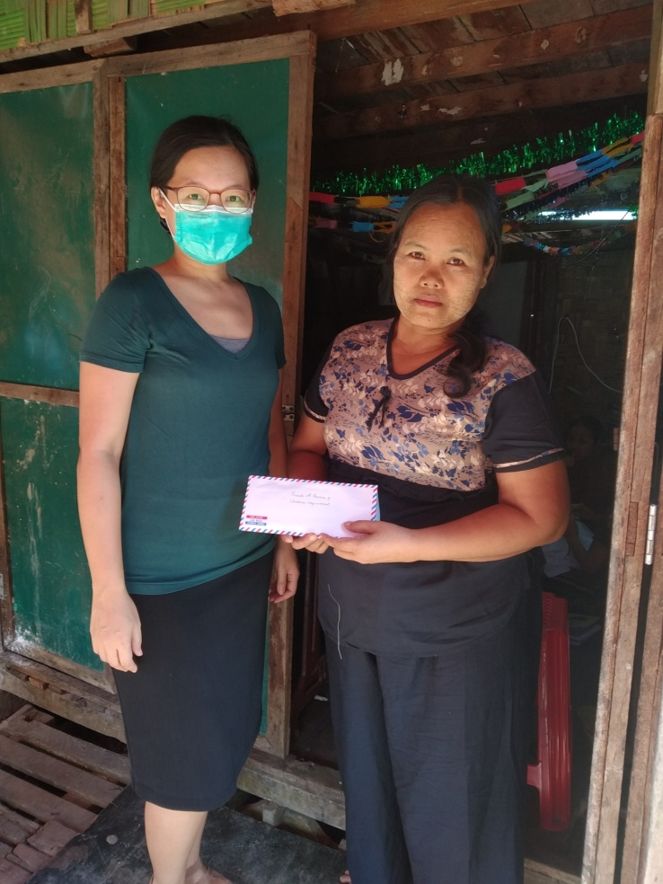#1 Dear Dr. Neil and Mrs. Diana Sowards and FOB donors,

I am Ruth Khin Aung from MIT's music department. It was my honor to have this wonderful opportunity to share FOB's Christmas gift to a lady who is in need of financial assistance. The following is my feedback after giving the gift to her.

1. How did you choose the recipient?

There are a few families and individuals in the area where I live (Insein-Taungthugone) to whom I have been delivering food and other essential items in several months. Among them, I found that the recipient, Ms. Ah Nay Paw, is one of the least who's in need of financial help.

2. What was the financial situation of the recipient?

Ms. Ah Nay Paw is a Kayar widow, who's taking care of her 10 year old daughter, her elderly mother, and two other boys who left their homes for the wars in their village in Kayar State, and currently living with her. She is running a small tailoring shop to support her family. With the pandemic and the coup, her business is not doing so well. She is basically trying to make ends meet by the little money she can make from tailoring and some food rations shared by a church she's going to.

3. What was the reaction of the recipient?

She was so surprised to receive the gift as she didn't expect anyone would bring such gift to her. She said she was thankful to the Lord and to FOB for the gift.

4. What was your experience?

When I heard that I was to give the gift to someone I know in need, I thought it could be difficult to make the choice to whom the gift should be given. But right at that moment, I saw this lady, and only this lady, in my mind.  Then, I felt joy in my heart as I saw her receiving the gift with a thankful heart. I thank God for his guidance, and I am so glad that I could be a part of sending FOB's Christmas gift to the needy.

I have attached to this email a picture taken in front of Ms. Paw's shop.

With Appreciation, Ruth Khin Aung

R

**********************************************************

#2 Dear Dr. Neil and Mrs Diana Sowards and FOB donors,

Thank you so much for your Christmas Gift which we have received through Sayama Fom Men.

The recipient is one of my guests, who came from Chin State to Yangon for Cancer treatment. She has been with us since 12th December 2020. She has five children and now her husband and children are struggling to meet their daily needs. Her family cannot afford for her medical treatment. Therefore, we ask financial help from relatives and friends for her treatment.

The recipient was so happy when I told her about the Christmas gift, her eyes filled with tears and said “Hallelujah”. The Christmas gift makes her day special.

I was so excited when Rev. Dr. Thomas Cung Bik told me about the Christmas gift, because the recipient is really in need and the Christmas gift is good news for me and for the recipient.

I really appreciate what you have done for the needy person. I wish and pray that May God Bless you more in the coming days and years. Thank you.  
  
With much love,  
  
Esther Hle Khia

**************************************************************

#3 I am Wu De Lay, a youth pastor from Man Hkring Lisu Baptist Church. I gave the Christmas gift from Friends of Burma to U Zaw Aung and this was my experience.

**U Zaw Aung**, a 73 year old, from Nang Jin Village: He is Burman. He converted to Christianity in about 20 years ago. He lived alone with no family members, in a small hut on a land owned by his friend. He suffered from a stroke a few years ago. His friends have been supportive of him since he has no family. People who lived in Nang Jin village do a living by making charcoal. He was very grateful to receive the gift and surprised to get it unexpectedly in a Christmas spirit.

**************************************************************

#4 I am Htoo Htoo Sah, a sister of Wu De Lay, and works as a minister at Man Hkring Lisu Baptist Church. This is my experience of giving the Christmas gift from FOB.

**Daw Lame Mee**, 81 years old from Man Hkring village: she lived with one of her grandchildren, who is 21 years old and works as a daily laborer. Most of the time she is alone in the house. She is very happy and smiling to receive the Christmas gift. For her, it means a lot. Since she is poor and only lived on the support of his grandson, the gift is a lot of help in this time of difficulty.

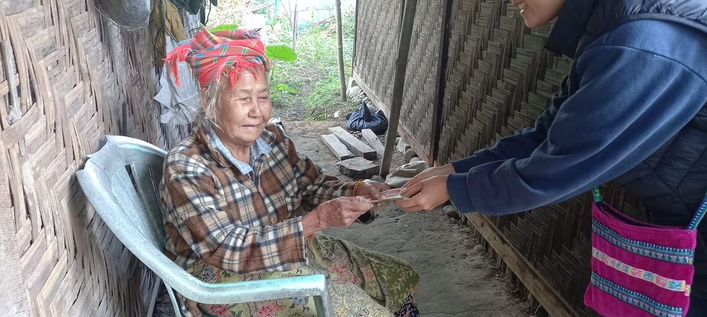

A report from U Shee Sho, one of the staff members at MIT.

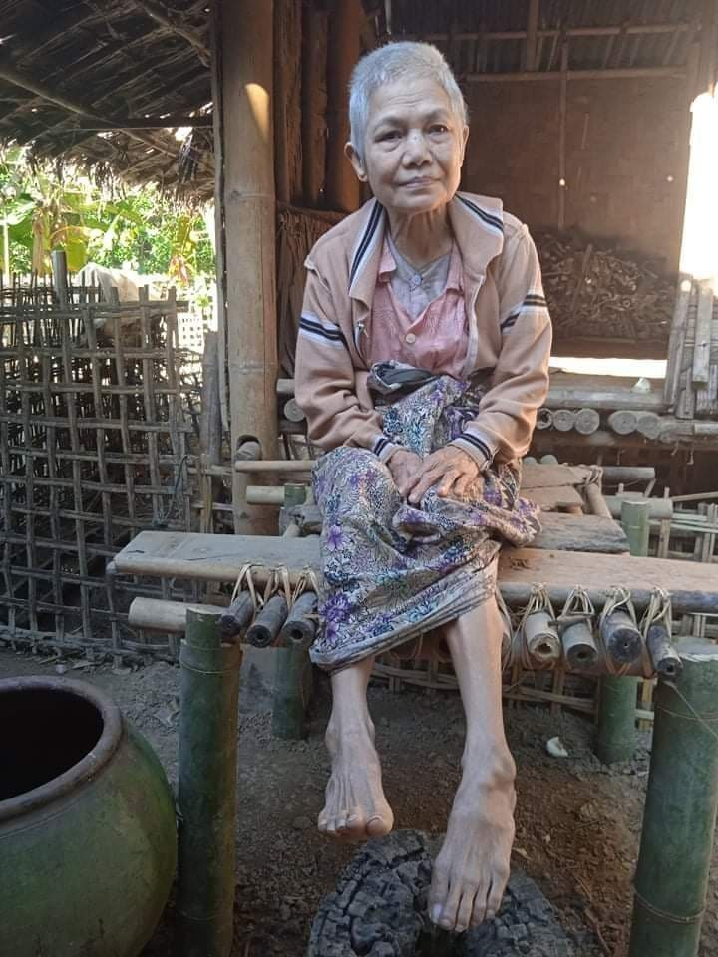#5 Dear Dr. Neil and Diana and FOB donors,

Attached is a report from U Shee Sho. He cannot write in English, so I told him to do it in Burmese. He sent his report to me via messenger (see attached), and I translated it.

U Shee Sho is one of my volunteers helping me whenever I went out to distribute rice and cooking oil to the needy. Although he does not know English, I asked him to give one Christmas gift to the most needy person he knows. He was very happy for the opportunity to do so.

Shalom,

Thomas

--

Rev. Thomas Cung Bik, PhD

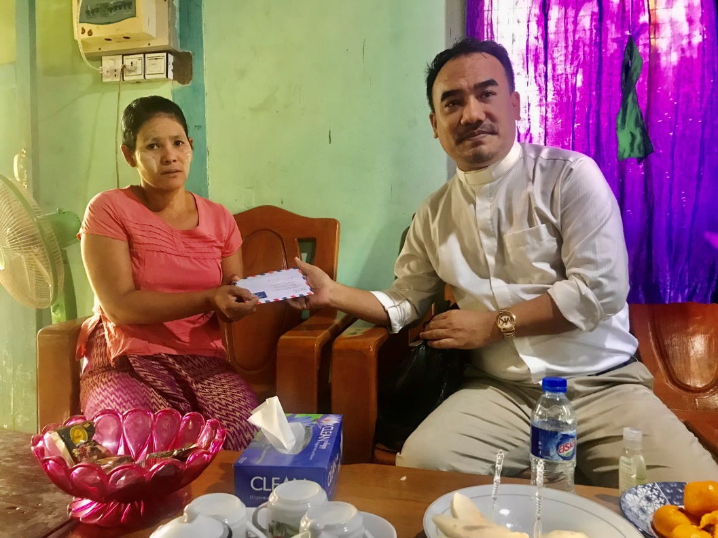#6 Dear Dr. Neil and Mrs. Diana Sowards and  
Friends of Burma  
  
I am very grateful for this opportunity to give your Christmas gift to the needy person. I chose Daw Khin Lay who has stones in her kidney. She does not have money to have a surgery to remove the stones from her kidney (which will cost about 1,000,000 kyats). She has been requesting us to pray for her. So I decided to give it to her.  
  
When Daw Khin Lay received your gift (90,000 kyats), she had tears in her eyes and said that God heard her prayers. Seeing her very happy made me very happy too. She was grateful to you for your Christmas gift. She prayed for you that God would bless you richly.  
  
May the joy and peace of Christmas be with you!  
  
In Christ's service,  
  
Rev. Victor Ceu Cung  
Soul Seeking Church (Pastor)  
09795581654

#7 A report from Mai Aye Aye Aung, former dean of Liberal Arts Program at MIT.

She sent me this report via messenger. Attached are screenshots of her message.

U Poe Sè is 73 years old man who used to work as a security guard at Asho Chin Baptist Church which is located in Insein Township, Yangon, Myanmar. His one eye got severe visual impairment due to a traumatic injury at work before he became a church security. Afterward, he worked as a faithful servant of God as a church security guard for almost 11 years until his both eyes were almost complete blindness because of the optic nerve damages. As a Church member, I had convinced his dedication and his dutiful performance throughout those years. Now, he is living with his brother’s family since he is a single old man without any income. I had a chance to go and visit his home this morning and gave a Christmas love gift in person. I can clearly see his joy over his face and I am sure that this Christmas sharing will benefit for him financially, 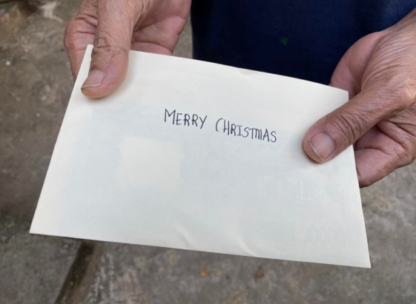physically, spiritually, and emotionally. Thank you all donors and contributors of this project. Merry Christmas.

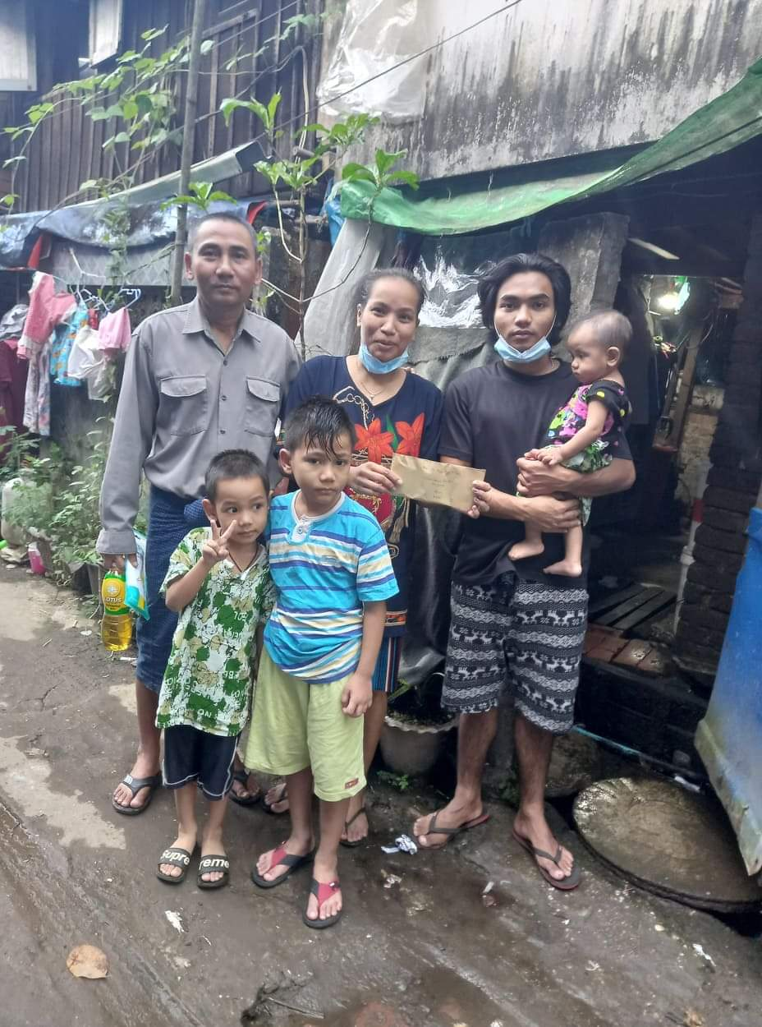

#8 Dear Dr. Neil and Mrs. Diana Sowards (FOB),  
  
This is to express my heartfelt thanks for your Christmas gift for the family, who are struggling for their daily life.  
  
The husband (U Than Tun Lay) was selling prata on the street before, but because of the effect of covid 19 and political situation it did not run well. Finally, he didn't have more money to invest and had to close down his shop. The wife works as a domestic helper and she has to leave her children at home in the daytime when she has got an offer to work. That means she cannot earn money everyday and it is hard for her to support her three sons for their education.The youngest one is only 11 months old and she has to leave the baby if she has to work. So I pickup their family as a needy one. I do believe your donation means a lot to them.  
  
Thanks again and may God bless you all.  
  
Blessings,  
Aye Aye Maw

#9 Dear Dr. Neil and Mrs. Diana Sowards  
  
Greetings from Myanmar!  
  
I am Kay Thi Htwe, one of the faculty members of Myanmar Institute of Theology. I am very glad to have had a chance to send your Christmas gift to the people in need.  
I walked around one of the suburban areas near my church on December 3 and a friend of mine who accompanied me informed me about some poor people who live in the area. Among them, I chose Chit Myat Noe to send her your Christmas gift. She is a nurse-aid and single mother. When she was six months pregnant, her husband abused her and lived with another married woman. Moreover, he spent most of his time gambling.  
  
After Chit Myat Noe gave birth to a baby girl, her husband left her and married another woman. Now she and the little baby girl are living with her widowed mother and fifteen year-old sister. She worked as a nurse-aid at a clinic before. Starting from the pregnancy and until now, she cannot work and does not have any earnings. Her mother is unemployed too. Some neighbors are helping her family by sharing food and supplies. They are surviving through the support of some neighbors and crisis response teams. I visited her on December 5 and gave her your Christmas gift. She told me that she has never received this kind of Christmas gift throughout her life. That is an unexpected and wonderful gift for her.    
  
The next day, She called and told me that she, for a month, had been wondering how to buy a birthday present for her daughter. Her daughter will turn one on December 8. Because this is the first birthday of her daughter, she wants to make it special for her little girl. She was very happy and told me how thankful she was .    
  
Thank you very much Dr. Thomas Cung Bik and Sayama Dr. Fom Men for asking me to pass this Christmas gift to those who are in need.  
               
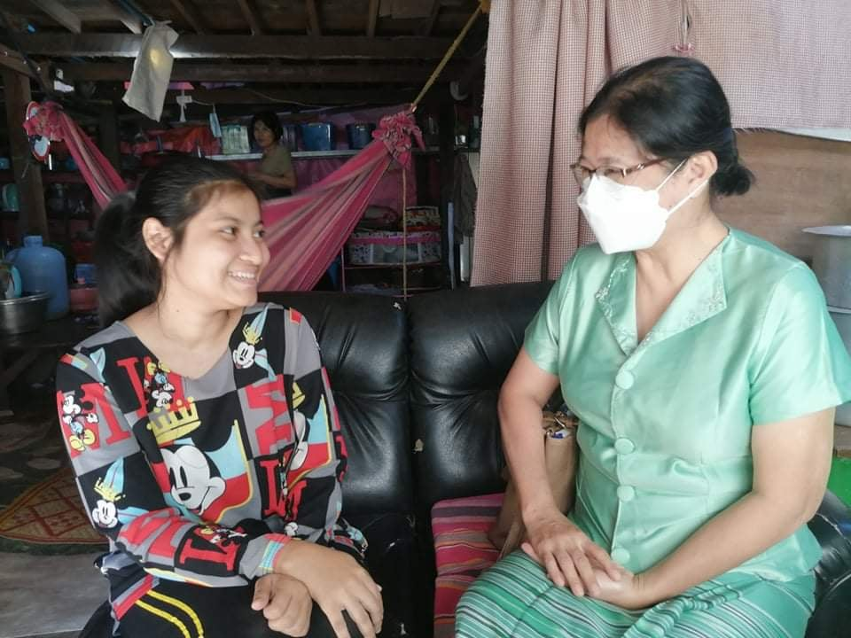Thank you very much Dr. Neil and Mrs. Diana Sowards for your love and kindness towards our people. You are the angels of God who proclaim good news of Jesus Christ and Santa Clauses who bring the love of God to those who are mourning this Christmas.  
  
May the Lord make His face shine upon you and be gracious to you. And May God bless both of you and your ministry.  
  
Sincerely,  
  
Kay Thi

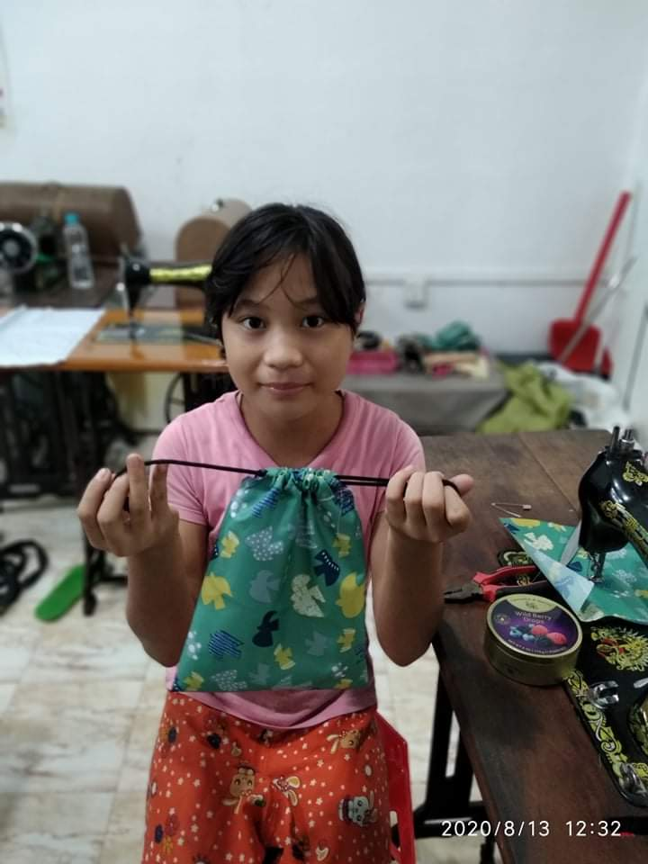#10 Dear Dr. Neil and Mrs Diana Sowards & FOB,  
  
Greetings! I'm Aye Min Khaing, one of the faculties of MIT. This email is to let you know the story of the Christmas Gift recipient.  
  
Aye @ Aye Su Mon is 12 years old, attended 5th grade in 2019. She is the 3rd child among 4 siblings. Her mother is a worker making a mosquito net where she earns 1500 kyats (which is less than a dollar with exchange rate these days) per item. Her father lost his job during Covid Pandemic and Coup. Her eldest brother works delivering beverages to diners around the neighborhood and he earns 6000 kyats (equal to about 3.5 $) a day and gives 4000 kyats (2 $) back to the family for food. Her second elder brother, herself and the youngest are dependents of the family.  
  
Aye joined the Sharing Love Program of Ywama Baptist Church to learn sewing and crochet. Though there are many children and related families who are in difficult situations, we chose Aye for her commitment towards her work, eagerness to learn new things and for her hard work. The parents find it very difficult to feed the whole family and it is sad to know that they won't let Aye attend the school when they are open again.  
  
Aye expressed her deepest gratitude to receive this Christmas Gift and was so surprised and happy to receive it. I'm sorry that I couldn't take the recent picture of her and the family because of many limited situations. I attached her pictures that I received from the Sharing Love Program. And of course, it is always a joy to help someone, to be a help for others especially during this Christmas Season.  
  
Thank you.  
  
Merry Christmas to you and your family.  
  
Carry each other's burdens and so you will fulfill the law of Christ.  
(Galatians 6:2)  
  
Aye Min Khaing  
Lecturer cum Graduate Studies Program Coordinator, Graduate Studies Office, Liberal Arts Program, Myanmar Institute of Theology

****************************************************************************************************

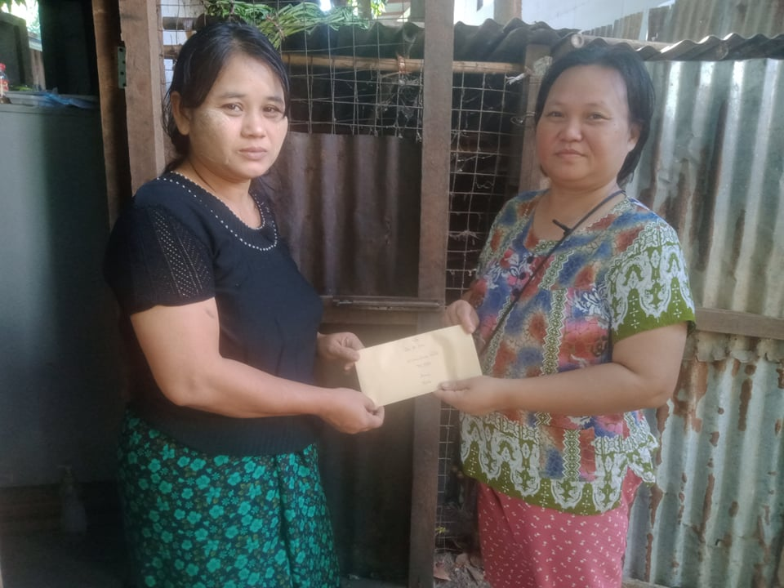

#11 A report from Dr. Ai Shu, Academic Dean at Pwo Kayin Theological Seminary.  
To Dr. Neil and Mrs. Diana Sowards and FOB,

Wishing you Merry Christmas

Firstly I thank God who gave me this opportunity to get in contact with you.

In Myanmar there are many people who faced many difficulties because of the military coup and Covid. There are many needy people around the country. Among them I choose one of the families to share your Christmas gift.

Lwin Lwin Aye is a mother of five children who flee from her own village because of political situation. She lived at Tha Byae Gone village, Twintay Township, Yangon, which is far away two hours by car from our compound, Ahlone.Her husband resisted the military coup who unjustly killed people. Therefore the military tries to arrest her husband so that he does not dare to live in his village . According to the brutality of the military, if they do not see the one they want they arrest the family members. So that, LwinLwin Aye and her childrens come and live at our compound. She is a poor daily worker in her village. When she arrived at our compound she was jobless and she faced many difficulties to feed her children. So, all of us try to take care of her whatever she needs. Sometimes she is really depressed because of her situation: no job, no income.

When she got support from FOB she was really happy. I saw a smile on her face. She said words of thanks to the donors who gave them Christmas present.

As I am Academic Dean at Pwo Kayin Theological Seminary as a house wife and a mother I am really busy. Many demands of our society push me to do more work. I try to help the needy as much as I can. I collected donations and help the needy. Sometimes I sell in order to get donation.Although I try my best it cannot fulfill the demand of the needy. Sometimes I feel really weak.

By the grace of God when I got information from FOB to give a Christmas gift for a family, I really thank God and also thank you for your concern and kindness to our needy.

May God bless you and your ministry!

In His Service,

Dr. Ai Shu. Academic Dean, Pwo Kayin Theological Seminary, Yangon, Myanmar

****************************************************************************************************

#12 A report from Nant Hlaing Yadana Soe who used to work at MIT. My husband provided a rough translation of her letter.

Dear Dr. Neil and Mrs Diana Sowards  
FOB

**Subject: Words of Gratitude for the Christmas Gift**

On December 5, 2021, with much thanks I received your Christmas gift (90,000) from Rev. Dr. Thomas Cung Bik. On December 8, 2021 when I was distributing some food items to needy families, I chose Daw Nora for your gift and gave it to her. Daw Nora moved to North Dagon from her village and lived there for many years. Last year, I was told, she moved to Hmawbi. She is a widow and she attends a church near her place where I first met her and know her. She has six children, and is now living with her two young sons in Hmawbi. During this difficult time, one of her sons was treated for heart problems at ER. In addition, her youngest son is a driver on highways and one night while he was driving, he was stopped and beaten by the soldiers, and he is now taking treatment. In addition to her struggle to feed the family, she now needs to pay for medical treatment for her two children. She is in a very difficult situation. As much as I could, I encouraged her, prayed for her, and gave her your Christmas gift. I told her about the gift, and she was very grateful.  
  
I would like to express my heartfelt thanks to you for your Christmas gift that Daw Nora received when she is in dire need.

May God give you the peace and joy of Christmas!

In Christ's service

Nant Hlaing Yadana Soe  
Kyo Tatar Pwo Kayin Baptist Church  
Founder, PHILO Care Ministry and Mental Health Services.

# 12 A report from Nant Hlaing Yadana Soe who used to work at MIT. My husband provided a rough translation of her letter.

Dear Dr. Neil and Mrs Diana Sowards  
FOB

**Subject: Words of Gratitude for the Christmas Gift**

On December 5, 2021, with much thanks I received your Christmas gift (90,000) from Rev. Dr. Thomas Cung Bik. On December 8, 2021 when I was distributing some food items to needy families, I chose Daw Nora for your gift and gave it to her. Daw Nora moved to North Dagon from her village and lived there for many years. Last year, I was told, she moved to Hmawbi. She is a widow and she attends a church near her place where I first met her and know her. She has six children, and is now living with her two young sons in Hmawbi. During this difficult time, one of her sons was treated for heart problems at ER. In addition, her youngest son is a driver on highways and one night while he was driving, he was stopped and beaten by the soldiers, and he is now taking treatment. In addition to her struggle to feed the family, she now needs to pay for medical treatment for her two children. She is in a very difficult situation. As much as I could, I encouraged her, prayed for her, and gave her your Christmas gift. I told her about the gift, and she was very grateful.  
  
I would like to express my heartfelt thanks to you for your Christmas gift that Daw Nora received when she is in dire need.

May God give you the peace and joy of Christmas!

In Christ's service

Nant Hlaing Yadana Soe  
Kyo Tatar Pwo Kayin Baptist Church  
Founder, PHILO Care Ministry and Mental Health Services.

****************************************************************************************************

#13 A report from Saya Myo Aung, a tutor at MIT.

Dear Dr. Neil and Mrs. Diana Sowards,

It was a privilege for me to participate in the Christmas Gift program, hosted by Friends of Burma (FOB). I prayed for the recipient and God showed her. It is Daw Aye Aye Khaing, mother of three children, widow as well. They are living in a slum area. They are very upset because the regime government forced them to remove from that area even though they the slip for living there. They have no income and her daughter has polio and she can not walk till her age of twelve now. They are facing a very hard situation for long but Christmas Gift program made them joy and happiness. I can not express their reaction because they all are very happy for having that Christmas Gift. I am also very pleased for that family. I am very sad because I have a chance to see their real situation. Their house is going to break down and they can not afford to mend it. Christmas Gift 90,000 ks made them to keep on for the living. Thank you so much for your concern for our people and such a precious gift for them. I made some attachments in this email. Please kindly see the attachments.

Blessing,

*Myo Aung, Tutor, Business Department, Liberal Arts Program, Myanmar Institute of Theology*

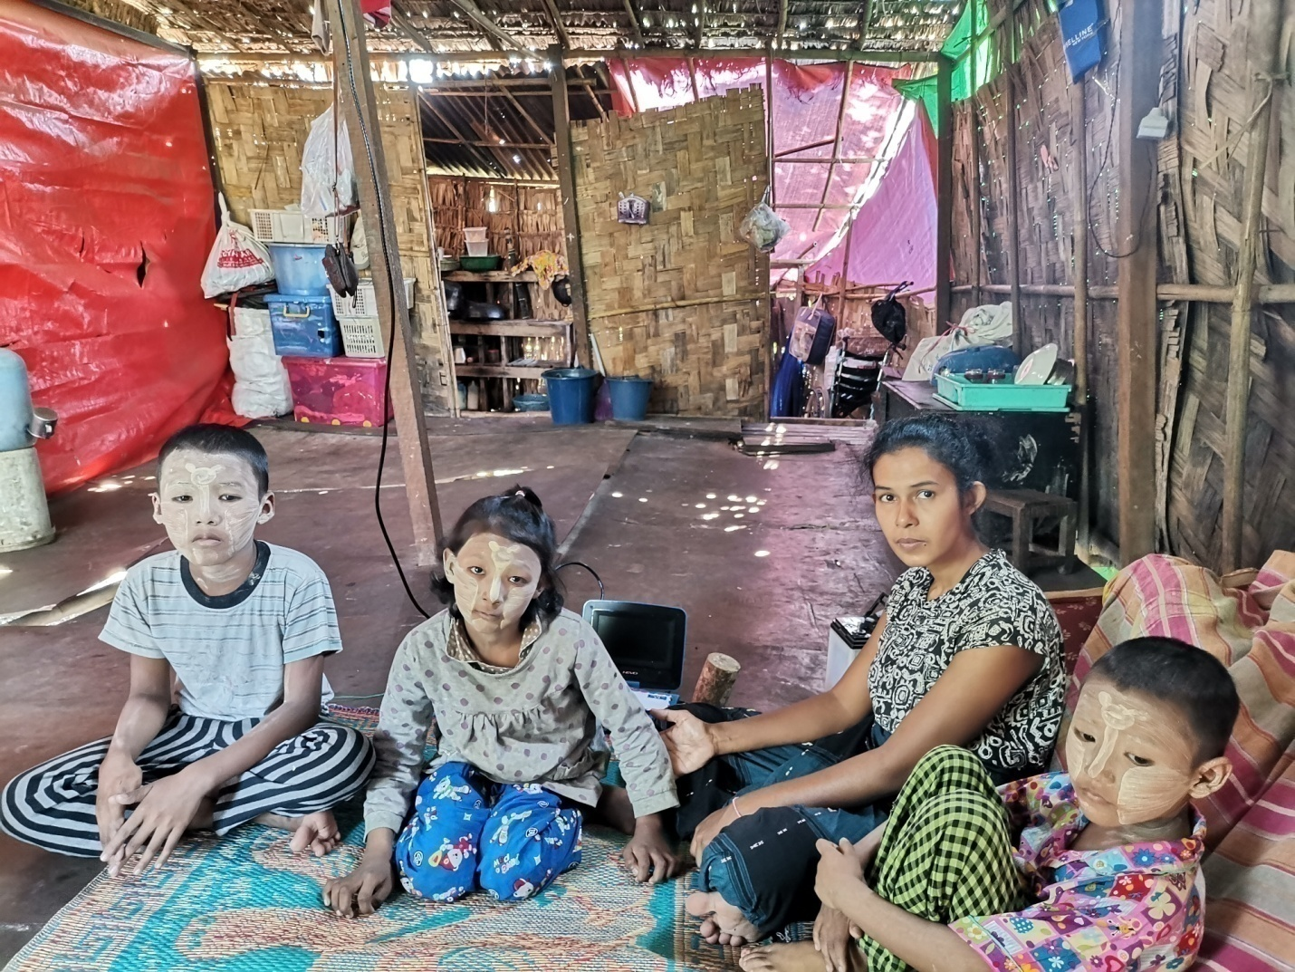

#14 Dear Dr. Neil Sowards and FOB Donors,

Thank you so much for your generous gift. We have given your Christmas gift to the mother who has difficulty to give a birth. But now, the baby was born well in this Christmas month. Both the mother and baby are healthy. This family was happy and thankful to you for your gift. Thank you again for your support.

Sincerely,

Nay Blut, Saw

#15 A report from Sayama Naw Phaw Eh Wah @ Gloria.  
Dear Dr. Neil and Mrs. Diana Sowards and (FOB),

Greeting you all in the name of our Lord Jesus Christ! Thanks be to God in the highest!

I am so glad to write a letter of thanks with lots of joy and happiness on behalf of Sayar Gideon Shwe (age 80). Sayar Gideon Shwe was the university chaplains of the campus of KyiMyinDine (R.C.3) University Christian Fellowship (UCF) after the years of 8888 uprising events followed by the unstable situation in our country. He faithfully served God while we were at the university. When we had KyiMyinDine U.C.F senior friends gathering in 2018, sayar came to that gathering with wheelchair because he could not walk as he had Post-polio disease again at the age of sixty. When I received your donation through sayar Thomas Cung Bik, I made a call to my friend who was staying near his apartment, and she said that sayar Gideon Shwe was currently suffering from stroke and cancer and was at the hospital.

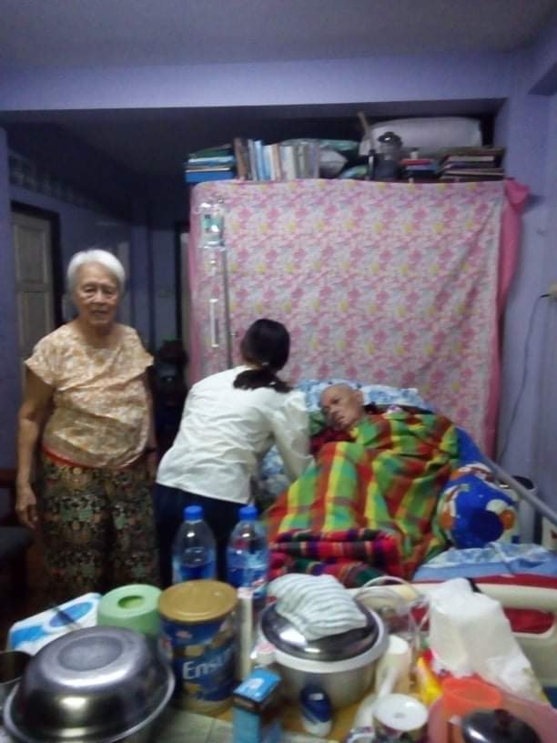As both of sayar’s daughters were married and have their own families, as sayar was 80 and his wife was 75, their financial situation might be very tight during this time of pandemic, crisis and hard situation. They were so thrilled to receive your love gift. They all were so glad to receive your donation and thank you all for your kindness and thoughtfulness. You truly made the difference for them, and they were extremely grateful for your love gift!

As for me, I could not give this amount of money on my own but because of your donation, we all can feel God’s presence, help, love, and care which change it to a blessed Christmas for all of us. Thank you very much for your generous donation. I went to sayar’s apartment with my cousin sister who knew Sayar Gideon while she was attending YaeZin Agriculture University and met him at YaeZin U.C.F. Because of your generosity, we have been able to send your gift 90,000 kyats which revealed God’s care and concern for them during this blue Christmas.  We took sayar and sayarma photo and attached it to this email. On behalf of Sayar Gideon, we really would like to thank you all for your generosity and appreciate your empathetic heart with great concern for them during this critical situation. We pray for you all to have God’s blessings abundantly and always.

With lots of gratitude,

Naw Phaw Eh Wah

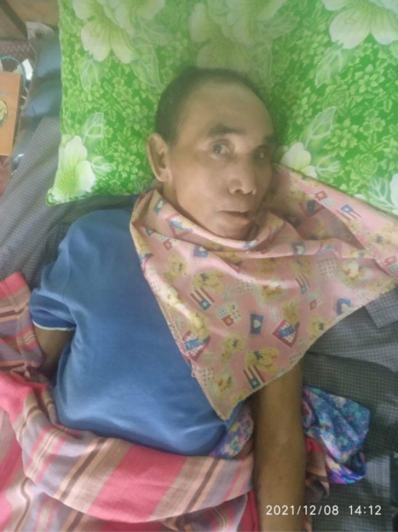*******************************************************

#16 A report from Dr. Pum Za Mang, a lecturer at MIT.  
Dear Dr. Neil and Mrs. Diana Sowards & (FOB),  
  
I choose this family, as I know well the uphill challenges they face for years after Pu Lian, the father, has been paralyzed for many years.  
  
The eldest son joined state police to bring food on the table, but left his job early this year as part of the civil disobedience movement in rejecting military rule. The family has no regular income since, and their financial situation is really bad. Pi Dar Van, the mother of the family, almost cried out of joy when she received this special Christmas gift (Ks. 900,00). It is always a joy and a blessing when I became a channel of blessings to others.   
Peace & Blessings,  
  
Pum Za Mang

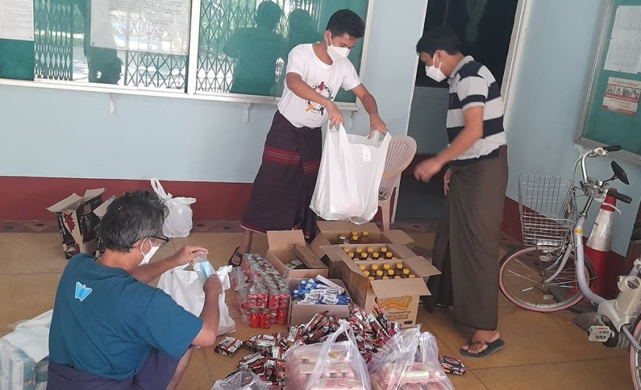

#17 Dear Dr. Neil and Diana,  
  
Sweet December and Merry Christmas!  
  
On behalf of my team (Saya Klo Htoo, Saya Allen Soe Oo,  U Saw Shee Sho, and me), I would like to express our gratitude to you and the donors for four Christmas gifts (4 x 90,000 = 360,000) which we used to buy Christmas gifts for the needy. We packed them into 35 bags (each bag has items such as cooking oil, canned fish, noodles, eggs, soap, toothpaste, some cookies, small cakes, and masks).  
  
This very early morning (December 11), we drove around the Insein township and visited dumpsters where the needy were collecting plastic bottles and other reusable items. Since they unexpectedly received the Christmas gifts, they were very happy and grateful, and their happy faces made us also very happy. This morning we could give your Christmas gifts to 35 needy people.  
  
My team and I are grateful to you for your Christmas gifts and for the opportunity to  give them to the needy in Insein township.  
  
May God continue to bless you and all the donors and give you the peace and joy of Christmas!  
  
Shalom, Thomas, Rev. Thomas Cung Bik, PhD, Coordinator of PhD Program, Myanmar Institute of Theology, Seminary Hill, Insein 11011, Yangon, Myanmar

****************************************************************************************************

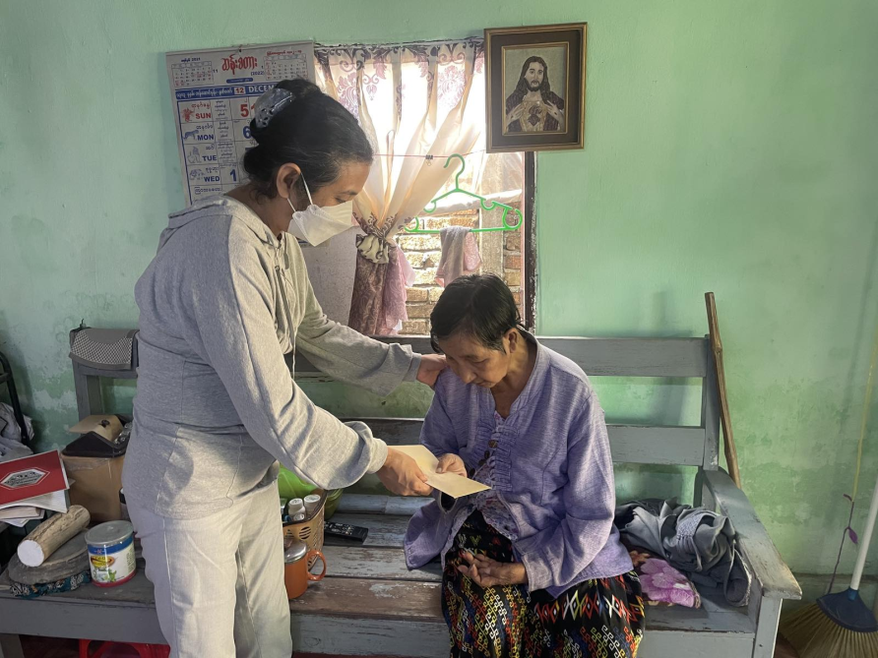#18 A report from Sayama Moe Moe Nyunt, Lecturer in Mission and Evangelism at MIT.  
  
Dear Dr. Neil and Mrs. Diana Sowards and  
Friends of Burma  
  
I am writing this email to mention that I am so much grateful to you for your kind Christmas gift.

As the recipient of the Christmas gift, I chose Daw Manthangi who has been suffering from stroke for over sixteen years. Financially, she needs to depend on her son and two daughters. Her eldest daughter's family is taking care of her wellness. (Her eldest daughter is a freelance evangelist.)

I visited and passed the gift to Daw Manthangi on December 9. She was surprised and became silent for a while when she received the gift. Then, she murmured the blessings upon you and me.

I thank God for you and Ms. Fom Men who helped one of my visions become reality. I am experiencing a meaningful Christmas season again. Yes, God hears my prayers one after another.  
  
May the Lord our God shower his blessings upon you, your family, and ministry!  
  
With Christ's love,  
  
Moe Moe

****************************************************************************************************

#19 A report from Rev. Dr. Soe Thiha, principal of Pwo Karen Theological Seminary.  
  
Dear Dr. Neil and Mrs. Diana Sowards and FOB donors,  
  
Last week I received 90000ks and sent it to Naw Ella,who is a gov high school teacher and now she is doing CDM. She is away from her family and hiding somewhere. She hasn't received her salary since May and really needs financial support. She was so active in her church activities and a good Christian. When she received your gift, she was so happy and sent me a thank you note in her Viber account. She could feel God's love through your gift.  
  
As I could handle your Christmas gift yearly, I am so honored and enjoying this ministry.  
Wishing you a very special Christmas.  
  
Take care.  
Soe Thiha

****************************************************************************************************

|  |  |  |  |
| --- | --- | --- | --- |
| #20 |  |  |  |
|  | | |

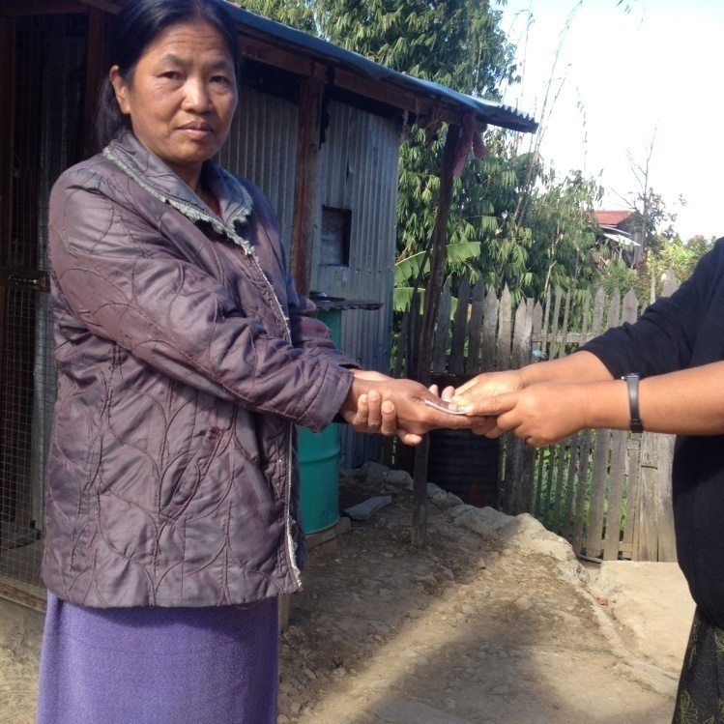Dear Dr. Neil and Diana and FOB donors,

Dr. Siang Zi, vice-president at Chin Christian University, could not open her email, so she called me and told me about the family she chose for your Christmas gift. She sent me the picture via messenger.

She gave the Christmas gift to Pi Hnem Khun who cannot speak. Her husband also cannot speak. They have one daughter. They are very poor. So she chose her to be the recipient of the Christmas gift.

Dr. Siang Zi was grateful for the opportunity to give it to the needy family who cannot speak and express their gratitude.

Sincerely,

Fom

#21 Dear Dr. Neil and Diana,

This is a report from Saya Chit Maung who is a pastor and missionary in Dala. He wrote his report in Burmese (attached) and my husband translated it.

Dear Dr. Neil and Mrs. Diana Sowards & FOB

Merry Christmas to you all

*My name is Khine Thazin. There are six members in my family. My father took any available jobs to feed our family. But after the Covid and political crisis, he cannot find any regular work. My mother and I sold water, but because of the situation in our country, people can no longer buy water from us. So we are struggling for our daily food. In this difficult time, my mother accidently stepped on a nail, but we would not take her to the hospital right away due to lack of money. But slowly the wound of her right foot became worse. My mother also has other health problems. We went to Yangon General Hospital for treatment, but there are not enough doctors there, and we have been there for a month. In order to attend the hospital, we borrowed money with an interest rate of 30 kyats. In this time of physically and mentally being very tired and stressed, we are thankful to God for this Christmas gift. We are very happy to receive it and pray that God will bless the donors richly.*

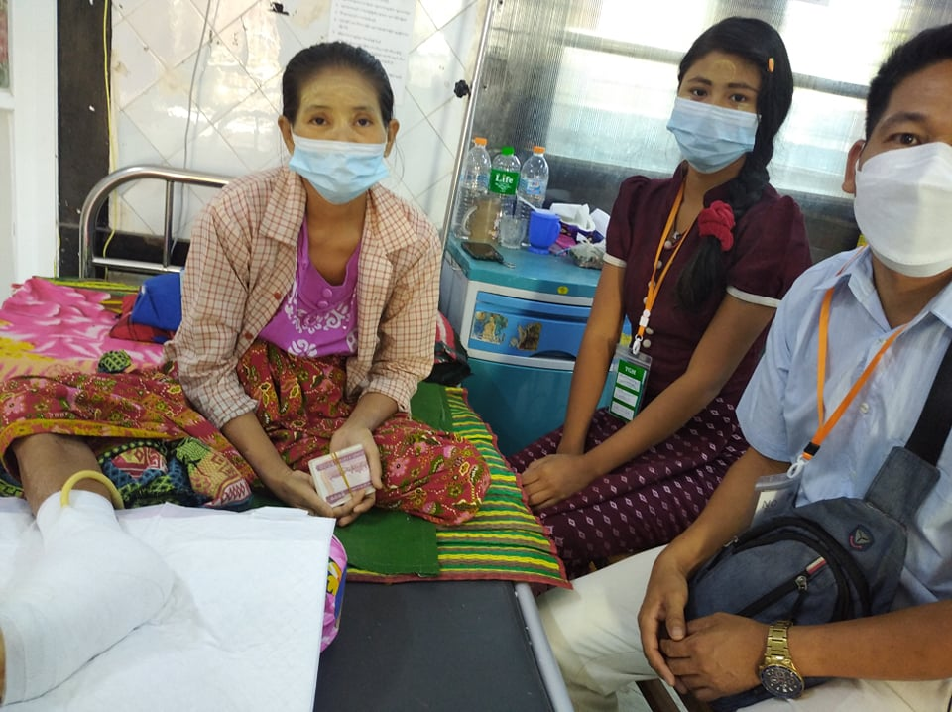

The above story was from Khine Thazin. I chose this family for your Christmas gift because when I looked at their family, I was very sorry for them. I also prayed that God would send them other helpers too.

I am very thankful to FOB for your gift for this family.

Chit Maung

Sincerely,

Fom

*****************************************************************************************

#22 To, Dr. Neil and Mrs. Diana Sowards & Friends of Burma

Report of Christmas Gift (Ks. 90000) from FOB

The Recipient Name: Daw Oak Loi (72 years)

Yangon Wa Baptist Church

Received Date: 13 th December 2021

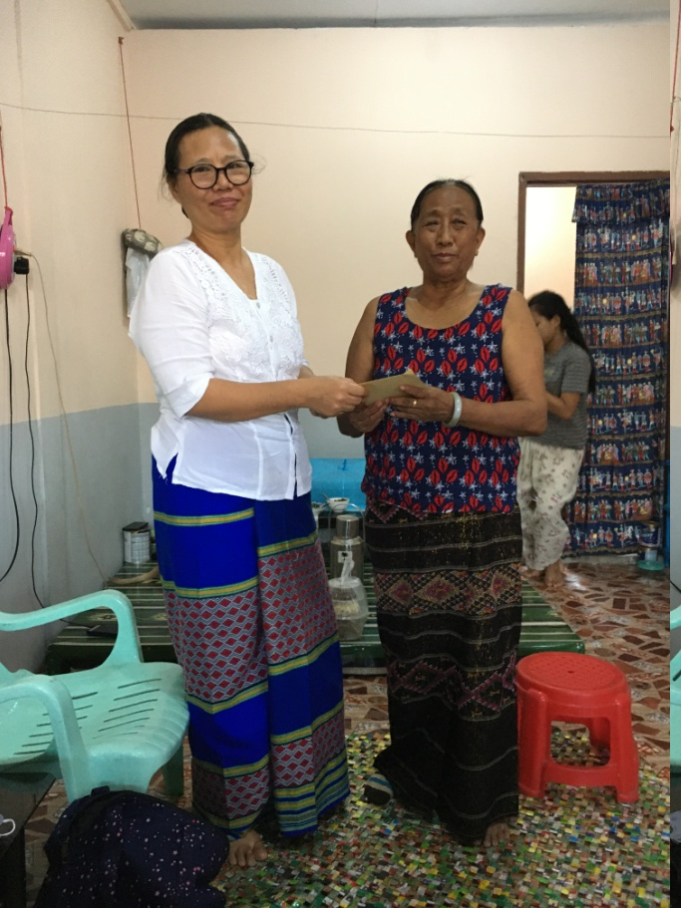1. I chose Daw Oak Loi as a recipient of Christmas Gift from Friends of Burma because she is really in need. She is a widow whose leg is broken a month ago. She is on medicating and financially she needs help.

2. As she is a widow, she doesn’t have income. She is relying on the support of her daughters and son. Her daughter is a minister in a church who does not have much income. Due to economic crisis in Myanmar, her daughters and son could not support her well.

3. I explained to her that I brought a Christmas Gift for her which is from the United States, she was surprised. Tears came from her eyes and she said, “God hears the prayers of a widow. I was serious ill during last two weeks because I could not take breathe well and went to hospital for oxygen. My leg was broken and I also needed medicating. I worried about my medicating costs. You bring to me a blessed Christmas gift. Thank God and donor who brought this gift to me.”

4. It was my great joy to bring good news to the needy person. I gave this Christmas gift to the recipient on her birthday service. It was really a great joy for her in receiving this Christmas gift on her birthday. She is a poor widow but she invited pastors and ministers at her place to pray for her. She gave thanks to God for saving her from dangerous sickness she faced. Her leg is on medicating and in good condition. Seeing her life struggles and the joys she has in times of difficulties, I am glad for having opportunity to send Christmas gift to the person who needs God’s care and love.

Rev.Dr. Aye Nwe

Yangon Wa Baptist Church

#22 A report from  Saya Obed Sui Lian Hre, an MDvi student at MIT who lives in Falam, Chin State. My husband knows him very well, so he asked him to give two Christmas gifts. This is his first report.  
  
Dear FOB,  
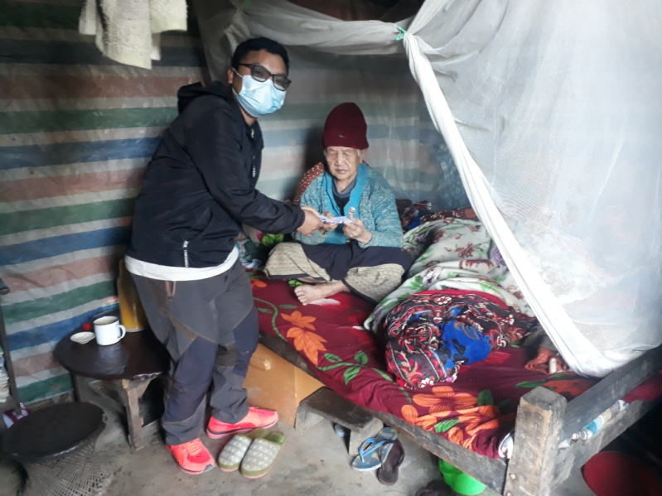  
Nu Peng Iang (age 89) was chosen to accept the Christmas gift. She has no support from her children because they are CDmers. They are actually difficult to live their daily life. When I gave gift, her face was full of happiness. Unfortunately, she can't hear and see anything, but her grandson told her that she got the Christmas gift. She said, "Even though I don't know who you are and which organization gave me a Christmas gift, God knows exactly, and May God bless my son and also the organization." Simply saying, when I gave her a gift, I was so happy indeed. At the same time, I am getting too enthusiastic to be involved in this kind of Charity work.  
  
Obed Sui Lian Hre, Falam Representative

**************************************************************************************************

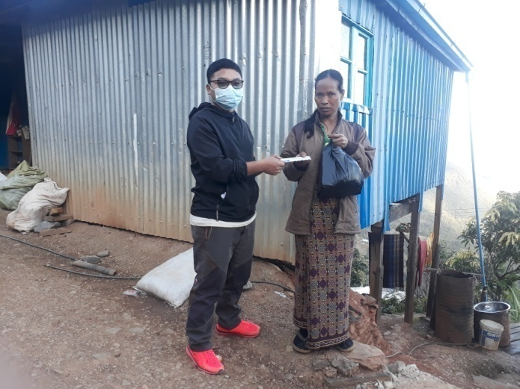#24 A report from Saya Obed Suilian Hre. This is the second report from him.  
  
Dear FOB,  
  
I chose Nu Zing Thluai (age 46) to accept the Christmas Gift that you prepared. I chose her because she and her husband live in Falam now because their house was burnt by the Myanmar military. They have no house in Falam, and they rent a small room in Falam. Indeed, she can't hear and speak anything, but she knows what we did (she can see). Her husband is about 70 years old and his left hand was cut and he can't do anything too. They are supported sometimes by Falam Volunteers and other organizations as well. They are really difficult financially. When I gave her, she was shocked and she looked at me strangely and I explained that she was given the Christmas gift, and her tears were falling down and she smiled. Her smiling makes me happy at the same time, and my tears fall too. Because I am so happy. Thank you so much FOB, God knows and notes your works. May God bless FOB and long live FOB!  
Obed Sui Lian Hre, Falam Representative

******************************************************************************

#25  16 Dec,2021 **Dear Dr. Nail and Mrs. Diana Sowards &  FOB.**

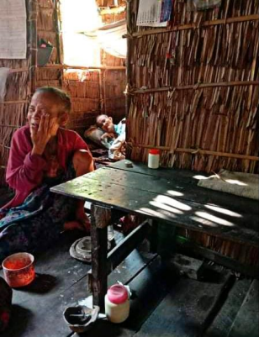I am writing this letter to express my sincere gratitude for giving me an opportunity to participate in “Christmas Gift” program made by Friends of Burma (FOB).

During the last week of November, I had received 90,000 MMK to help the most needed person around me. I had a conversation with one of my staff about this program and he told me about  a woman who lives in his native village called ‘Tanggyi’ of Kangyidaunt Township in Delta Region.  Her name is Aunty Tala and 60 years old now staying with her two sisters in a tiny bamboo house.  Her elder sister is a widow and the younger one is a spinster who is the only one that can support  the family.

The main economic in Delta Region is agriculture. Before transition from hand production to  machines, women could get regular earnings by working in the farms, but their daily incomes are  not sure for nowadays. In such a way, Aunty Tala’s sister can go to the farm at only two rice planting seasons during a year and can get some incomes. For other seasons, she has no regular  incomes but has a chance to collect some rice stalks that left in the field during the harvest time.  So that the family can meet their daily need for food. Extra income for health care and other  expenses are not sure for the family.

This story reminded me of the ‘Book of Ruth’ and I decided to give 90,000 MMK Gift to Aunty  Tala’s Family. So I transferred it to her through Wave Money (One of Myanmar mobile Financial  Services Providers). Aunty Tala’s younger sister cashed out the money and I got a chance to make  a call with her. She was excited to receive that gift because the family never expected to get such  amount of money as a Christmas gift. She said that she could buy rice bags for about three  months and some drugs for Aunty Tala and the oldest one. She said “thank and GOD bless to all  the donors” instead of Aunty Tala because aunty is a woman with congenital disability and can’t  reply to my call.

I am blessed to participate in this program and let me say thank you once again. Let me attach  one photo of Aunty Tala that I received from my staff. I am sorry for the quality of the photo. In  this photo, what we can see is Aunty Tala putting Thanaka (Myanmar traditional powder for skin  care purpose) on her smiley face. Thank you for taking time to read my letter.

Respectfully,  Allen Soe Oo, Property Supervisor, Myanmar Institute of Theology

Photo: Aunty Tala putting Thanaka paste on her face.

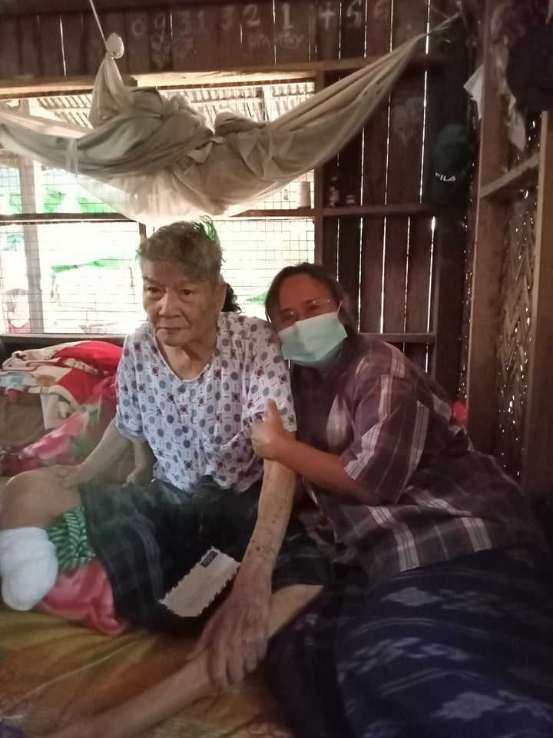#26 A report from Sayama Tha Khu Hla. This is her first report.

Dear Dr. Neil and Diana and FOB Donors,

We gave two Christmas gifts to Sayama Tha Khu Hla so that she would choose two needy persons and give the Christmas gifts to them. She sent me the following report via messenger.

I chose a retired pastor who is poor. He does not have a house. His children are also very poor. So he was in a very difficult situation. In addition, his right leg was amputated only a few days ago. He still needs to go back to the hospital. I gave him a Christmas gift of 90,000 from FOB. He said that he was very grateful for the gift.

 Sayama Tha Khu Hla

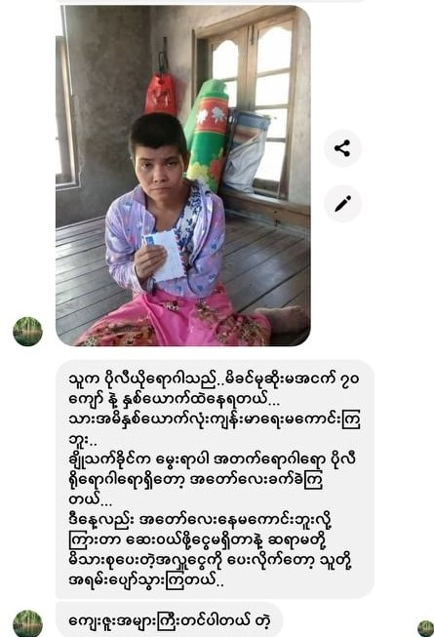

# 27 A report from Sayama Tha Khu Hla. This is her second report.

Dear Dr. Neil and Diana and FOB Donors,

Sayama Tha Khu Hla chose Nant Cho Thet Khaing who was infected with polio. She wrote to me as follows:

Cho Thet Khaing is suffering from polio and is living with her widow mother who is about 70 years old. They both have health problems. Since she has polio, they are in a very difficult situation. Today she was very ill and they did not have money to buy medicines. When they received the Christmas gift, they were very happy and said that they were very grateful for the gift .

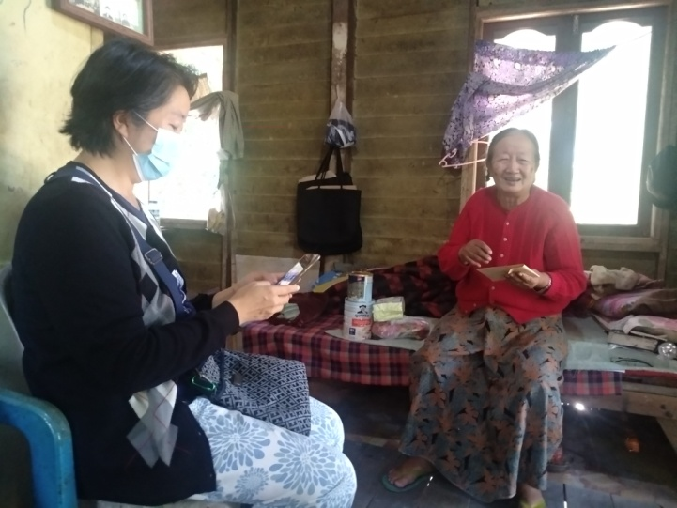*****************************************************************************************#28  A report from Sayama D. Nang Ram, a recent MDiv graduate of MIT.  
  
Dear Dr. Neil and Diana and FOB Donors,

Sayama D. Nang Ram sent a report in Burmese, and the rough translation is provided below.

I gave the Christmas gift to Sayama Maran Ah Ja. She was one of the ministers of MYC (Myanmar Young Crusaders) and now lives alone on the campus of the training school in Hmawbi. She is a widow, but her children or grandchildren cannot support her. The school supports her 20,000 kyats with some food per month.

Currently she has diabetes and kidney problems. Her right arm was broken and a metal was inserted in it. Since she has no one to help her and needs financial help for her medical expenses, we went to give the gift to her.

We told her that the Christmas gift was from FOB. When she received the gift unexpectedly, she was surprised and happily received it. She told us how good God has been to her and prayed for you.

I was also happy for this opportunity to be able to pass on the gift to the needy person. I felt called to do as much as I can for the needy and to take care of elderly people. In the days to come, if I can be of any help, please let me know.

Thank you for asking me to do this.

D. Nang Ram.

#29 5 Dev 2021

To Dr Neil and Mrs Diana Sowards and FOB

Subject: Christmas Gift 90,000 MMK

It is my great pleasure to write this report on a wonderful program called “Christmas Gift” from Dr Neil and Mrs Diana Sowards. The recipient of the gift is Mr Jang Tin Sei. He is a B.Th 3 rd year student at Tedim Christian College, Yangon. He lost his father while he was in B.Th 1 st Year. His mother has no job due to poor health. As his family cannot support his study at TCC, the College takes care of his study expenses by looking for scholarships from wellwishers. Thus, this Christmas Gift 90,000 MMK is very meaningful for his study life. I see that he is very happy to receive this surprising gift and I also feel very proud to assist this program. Yours sincerely, Rev. Dr. Nang Sawm Piang Principal

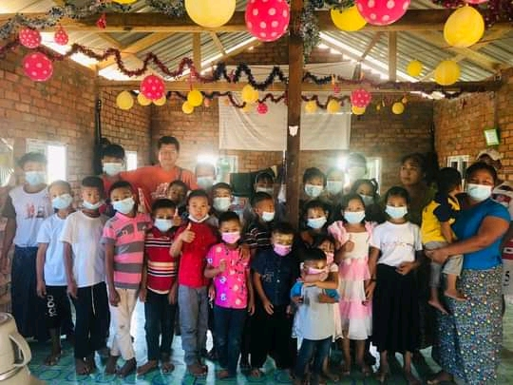

#30 A report from Saya Htoo Htoo Wah, lecturer in English at MIT.

Dear Dr. Neil and Mrs. Diana Sowards and FOB Donors,

I am writing to express my heartfelt gratitude to you for your Christmas love gift (90,000 kyats) given to me by Sayama Dr. Fom Men and Saya Rev. Dr. Thomas Cung Bik. Yesterday I gave this love gift to an orphanage called "New Life" situated in a village in Taik Kyi Township, Yangon. This orphanage is being operated by Saya U Saung (a seminary graduate) and his wife Naw Eh Ka Lu Htoo. There are 24 children in this orphanage who range in age from 3 to 16 years.

Due to the present political situation here, these children do not go to school. A lady is helping them with their school lessons. Their monthly expense is around 800,000- 1,000,000 kyats (not including school expenses if they go to school). They do receive donations sometimes. To generate and supplement income, they grow vegetables and breed a few cows, chickens, ducks, goats, fish, etc. If needed, Saya U Saung (His children call him "Ah Pa" (daddy)) is not hesitant to do odd jobs to feed his children. The children are found to be well taken care of and  well-behaved.

They are very happy to receive not only your donation but also us (I went there with my wife and two staff from MIT). With the children, we talked, we sang and we ate. The children were excited and happy by our visit. Who would not when shown love and care especially at Christmas time. We are as happy as them also because we, through your help, are able to do something for the needy.

On this visit, I also gave them other donations given to me by a few other donors (The total amount I gave them yesterday was 300,000 kyats). After visiting them in person, I came to know some immediate needs of theirs and now I am talking over with some of my friends to fulfill some of those needs.

Last year you also gave me an opportunity to share your Christmas love gift with two needy persons (One old and poor man who died a couple of months ago, and a Christian minister who is battling with cancer- she  is still living).

Again, thank you very much for your love, care and concern for the needy people here. I also thank Dr. Fom Men and Rev. Dr. Thomas for being a channel of blessing.

May God continue to bless you, your family and your ministry abundantly.

In Christ, Htoo Htoo Wah, Myanmar Institute of Theology

#31 A report from Saya Chit Maung and sent to me by my husband.

Dear Dr. Neil and Diana Sowards and FOB Donors,  
  
I asked Saya Chit Maung (a missionary in Dala, Yangon) to give two Christmas gifts to two needy families. He came to collect the gifts and told me that he would give one gift to a needy family (see **Report - 20**) and the other gift to another poor family. He advised the father of the second family to drive a tricycle to make some money for his family. So he borrowed a tricycle (see pic. 1). He had to pay 1000 kyats per day to the owner. On average he could make about 3000-4000 kyats per day, but after paying 1000 kyats to the owner, he would have 2000-3000 for his family. Saya Chit Maung mentioned that if he owns his own tricycle, he will not need to pay for the rental and will be able to earn more for his family.  
  
I asked Saya Chit Maung how much would be the current price of the tricycle that he had borrowed. He said it would cost between 150,000 and 180,000 (new ones will cost more than 400,000). Then, I strongly felt that we should give two Christmas gifts to Ko Nyi to buy a tricycle which will help his family tremendously and will be used for years. So I gave two Christmas gifts (2 x 90,000 = 180,000) to Saya Chit Maung to buy a tricycle for this family. Saya Chit Maung later told me that he and Ko Nyi bought a tricycle (pic below) with 170,000 kyats and the rest (10,000) would be for their immediate use.  
  
I translated Saya Chit Maung's letter in Burmese as follows:

Dear Dr. Neil and Mrs. Diana Sowards and FOB donors,

Merry Christmas to you all.

I chose Ko Nyi's family for the Christmas gift. There are five members in his family including his mother. He worked any available jobs to earn a living for his family. His mother and wife collected bottles along Ayeyarwady River. Sometimes they picked betel nuts and sold them. Since he could not find any other job, Ko Nyi borrowed a tricycle to make money for the family. I chose the family for this reason.

Ko Nyi said that he was very happy and grateful for a Christmas gift of a tricycle for his family. He was very happy to receive it unexpectedly and how much he was grateful is beyond what he could express. He was grateful to you and the donors and prayed that God would bless you more.

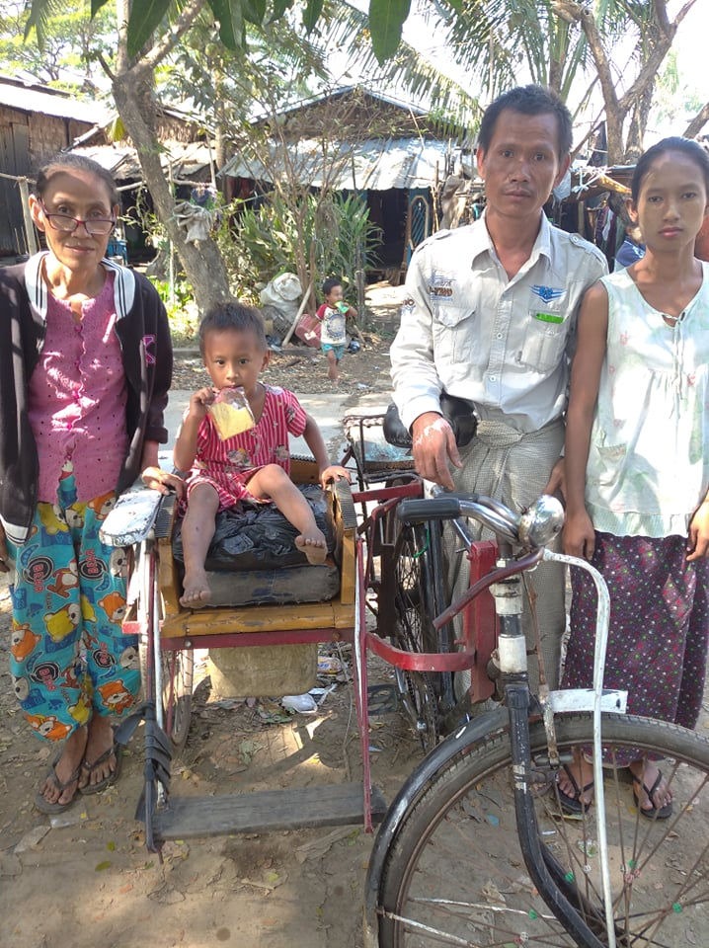My family and I live and work as a missionary in Dala.  Here most of the people are not educated and they are very poor. Some people sold water to earn a living. But after the virus and the coup, many people who used to buy water from them could no longer buy it from them. So they are in a very difficult situation.

Saya Chit Maung

I am also very happy that we made this decision to give two Christmas gifts to buy a tricycle for Ko Nyi's family. Your gifts made this Christmas more meaningful and special for this family.

Shalom,  
  
Rev. Thomas Cung Bik, PhD  
Coordinator of PhD Program  
Myanmar Institute of Theology  
Seminary Hill, Insein 11011  
Yangon, Myanmar

#32 To, Dr. Neil and Mrs. Diana Sowards and FOB Donors, Friends of Burma

The Christmas gift of 90,000 ks. (Ninety thousand Myanmar kyats) donated by Friends of Burma was given to Mrs. Ing Taik, a Cancer patient lying down at Thiri Sandar Hospital in Yangon for major operation. Living in a remote village with no financial income, her family face financial difficulty even for their living let alone for her treatment. But since the doctor told them that she would die soon unless she takes immediate operation, they borrowed money from neighbors and brought her Yangon from far away even though there were some difficulties and challenges to travel during the current political situation in the country.

It was the first and unexpected Christmas gift for her. Feeling unloved, forgotten and even hopeless at hospital, she could not feel the joy of Christmas this year. But the gift renewed her hope and joy. When she received the gift, she praised God, saying, “God has never forgotten me,

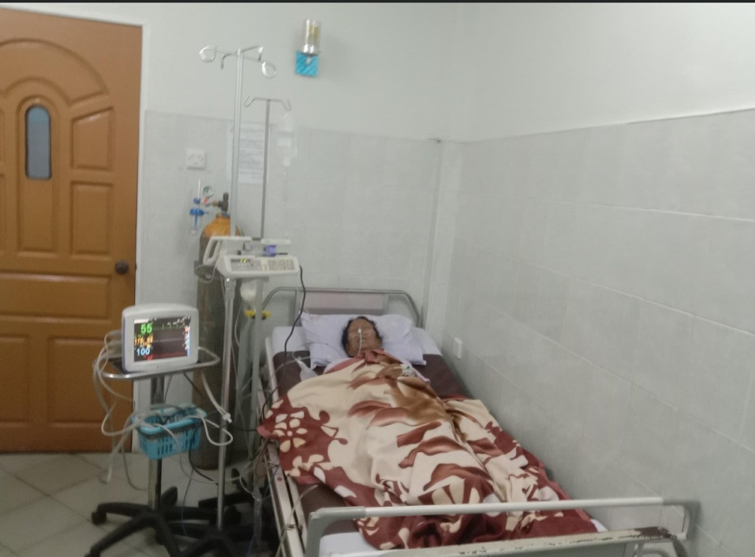but always remembered me.” And she also expressed her gratitude to Friends of Burma, “Thank you to the donors for blessing me with this gift. It is the first Christmas gift for me this year. It helps me feel special and God’s love.”

I was touched when I saw joy and hope on her face when I gave the Christmas gift and said a prayer for her at hospital. The inner joy came to my mind from helping her and praying for her when she responded “Thank you” and “Amen.” The feeling confirmed that Christmas is truly a season for remembering others especially the needy, the sick and the poor. Christmas was not a season to celebrate for her, but she deserved Christmas gift. But I observed the Christmas gift meant a lot for her it reminded her of God being with her with unfailing love.

Thank you, Swe Maung

****************************************************************************************************

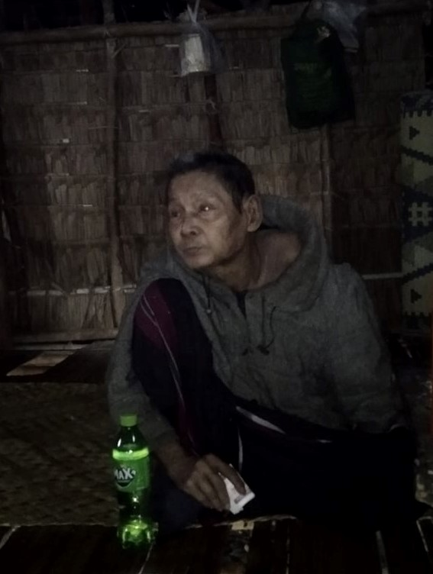

#33 A report from Dr. Saw Shwe Gyan, vice principal of Karen Baptist Theological Seminary.

Dear Dr. Neil and Mrs Diana Sowards, Friends of Burma,

Greetings from Burma!

I am a minister working at a Bible School in Yangon. I usually visit churches and villages to see the real situation in the community. During this Christmas holidays, I went back to my village situated in Ayeyawady Division and celebrated Christmas together with my family and villagers for a couple of days. One evening, I visited Hpu Maw Din, a poor elder about 80 years old who lives alone in his small house. Hpu Maw Din told me that he has five children, but now four of them have already got married and live separately, but have to struggle for their daily survival. Currently, his youngest daughter lives with him, but always has to go out and work hard for daily basic food. Currently, it is very hard for him to survive. After having talked with Hpu Maw Din, I had compassion on him and I gave him the love gifts with me from Friends of Burma. He was so amazed and joyfully said, “Thank you very much. I am very happy with your Christmas present.” I explain that this Christmas present is from the Friends of Burma, a tender loving care group which loves people living in Myanmar like you. After that he said, “Send my very special thanks and prayer to the Friend of Burma. May our heavenly God bless FOB abundantly.” Then, I went back home with satisfaction and a good feeling of a meaningful Christmas by sharing a Christmas present on behalf of FOB.

 Best Regards, Saw Shwe Gyan,

****************************************************************************************************

#34 A report from Saya Mana Tun, a lecturer and director of Peace Studies Center at MIT.

I feel so blessed and privileged to participate in your Christmas Gift program in December, 2021.

When I was asked to choose someone in need, one family, a family of three, that actually needed such gift, suddenly came into my mind. U Mana Hung, a father, has not been able to work a proper job for more than ten years. Daw San Thi Win, a mother, has been working on daily wage jobs and due to Covid-19 pandemic and military coup in Myanmar, she was unable to find such usual daily wage jobs. The two parents, including their six years old son Arkar Thang Mana, got infected with Covid-19 in September, 2021, and suffered serious health impacts for subsequent months. In the last week of November, their son (6 years old) got into an accident with a bicycle and injured his leg really bad. I called U Mana Hung and he came to my house early morning on December 1, and received the Christmas gift, 90,000 kyats, with a big smile and surprise. U Mana Hung was so happy and he prayed that God would return many blessings to the donors and program.

As for me, I felt like I saw with my own eyes how a special prayer was answered by God. I knew that U Mana Hung’s family desperately prayed for help as they seriously needed. By God’s grace, U Mana Hung’s son has recovered from the injuries and bruises and the family’s Christmas season was helped/blessed by the Christmas Gift. So, it was indeed a kind of fulfilling /satisfying experience to see and witness how the Christmas Gift, 90,000 kyats made an impact in terms of health, happiness and faith. With deep gratitude,

Mana Tun

******************************************************************************

#35 & 36  report from Dr. Paw Lar Say, associate professor in the Liberal Arts Program of MIT.

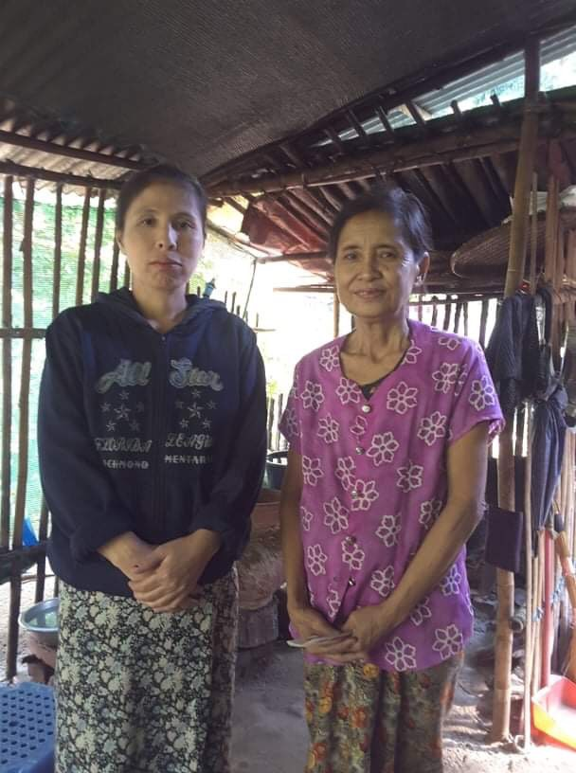Dear Dr. Neil and Mrs. Diana Sowards and FOB Donors,

Wishing you A Merry Christmas and a Happy New Year too!

First of all, I would like to say thank you so much for the Christmas gifts (90000 MMK/per) especially for the two women (photo attached) in this Christmas time, 2021.

In fact, there are so many needy families surrounding us in Toungoo (Kyauk-Twin village) and it is quite difficult to choose for this Christmas gift. But, as I'm working with those needy families during these severe hardship times, I have chosen the two women whom I saw as the most needed.

The first one (black color one) is a single mother who has two kids (13 and 9 year-old) and also has a widow mother (one grandmother) and there are 4 members in her family. She is the one who is taking care of her two kids and an old aged mother by doing hand weaving. She said with tears that she is so happy to receive a Christmas gift like this and she thanks God and also says thank you so much to FOB. And said she will buy rice first and for the rest she will buy and do hand weaving (Karen traditional dresses) to earn money for their living.

For the second one, she just stayed with her husband, only two of them at home as their young daughter is working in Maesot and didn’t get any news from their daughter for two years. Life is so difficult even for their daily food. She said she thanks God that she has received this (90000 ks) X'mas gift as she never received this in her life. She will buy rice and medicine as she and her husband need some rice and medicines as they are suffering from Covid 19 - corona virus.

My heart is filled with joy and love for the blessings especially for the two needy families during this Christmas season. And I believe that surely the families would feel God’s love through FOB’s loving care and great concern in this Christmas time.

Thanks for making this Christmas a special and a meaningful Christmas for those families.

May God continue to be with FOB and more blessings to encourage others in the future.

PawLar

****************************************************************************

#37 A report from Rev. Dr. Thomas Cung Bik, Associate Professor of Old Testament at MIT.

Dear Dr. Neil and Diana Sowards and FOB Donors,

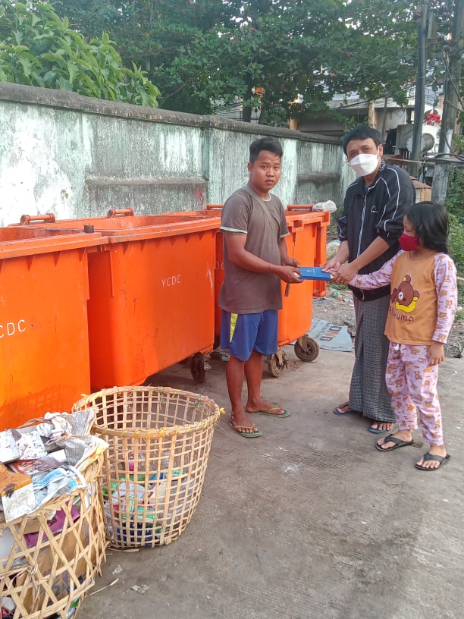I would like to wish you a blessed New Year 2022. There is a grocery store called STAR not far from MIT. We usually walk there to buy basic necessities. Every time I went there,  I passed by a dumpster and saw this young man trying to collect any reusable and recyclable items such as bottles that he could sell. I spoke to him and asked him how much he made by selling them. He said on average he made three-four thousand per day. He has a wife who cannot find any job at this time, and they have a six-year old boy and a two-year old girl.

The day before Christmas my family and I walked there and met with him again. This time we gave him your Christmas gift of 90,000 kyats. We told him that we are Christians and that this Christmas gift was from you who cared about people in Myanmar. We also shared the good news of Jesus Christ and along with the gift we gave him a small Bible. Since he received it unexpectedly, he was very happy and thanked us and you for this gift. He told us that he had borrowed some money from his neighbors and he would use it to pay back his debt, and the rest he would use for his family. He said that he could not work every day or there are days he cannot make any money. He said this would help his family tremendously.

My wife and I took our two children, and this was a good opportunity to teach our children how to be kind to the needy and that there are many needy people like him who need help. They were also happy to be able to give the gift to this needy man.

Thank you very much for your Christmas gift for this man and his family! May God continue to bless you!

Shalom, Rev. Thomas Cung Bik, PhD, Coordinator of PhD Program, Myanmar Institute of Theology  
Seminary Hill, Insein 11011, Yangon, Myanmar

 A report from Rev. Dr. Thomas Cung Bik, Associate Professor of Old Testament at MIT.

#38 & 39 A report from Sayama Seng Tawng, Lecturer at MIT.

Dear Friends of Burma in Christ,

I am Miss Seng Tawng from Myanmar Institute of Theology(MIT). I have been teaching Old Testament subjects since 2010 at MIT. I kindly received 100 US dollars from Dr. Fom Men to give Christmas gifts for two persons who are from Kachin State. I have given these Christmas gifts of 50US Dollars each to Saya Jawng Li and Daw Sana Lu.

**Saya Jawng Li** was a former Bible translator of the Kachin Baptist Convention for at least ten years. He has been paralyzed for eight months. He needs medical cover. He really expressed his words of thanks to Friends of Burma who kindly supported this Christmas gift of 50 US dollars for his medical treatment process.

**Daw Sana Lu** is a widow and her house is built with a bamboo hut. It is nearly falling down. She needs to make a better shelter for her safety. She felt thankful to Friends of Burma who shared a Christmas gift of 50US dollars that she can spend for renovating her house.

There are no words that can express our thanks. May God continue to bless your mission wonderfully!

In the service of Christ Jesus,

Seng Tawng, Lecturer, Biblical Department, Myanmar Institute of Theology (MIT), Seminary Hill, Insein, Yangon, Myanmar

|  |  |  |  |
| --- | --- | --- | --- |
| #40 A report from Sayama Myat Thu Zar Win who lives in Hmwele village, Gangaw Township. |  |  |  |
|  | | |

Dear Dr. Neil and Mrs. Diana Sowards and FOB Donors,

Firstly, I give my heartfelt thanks to God and all of FOB donors. I would like to report about the donation given to the family who is in need. The reason why I chose them is for they have no income in this tragic time. They have no house either, so they have to rent a house to live there and also have some debts to solve their basic needs. Besides, they have a newly born child, so I thought they are the most suitable family to receive the donation.

When they received the donation, they were so glad for it was an unexpected Christmas gift for them. They said thankful words to God and wished many blessings for the donors while wearing their sweetest smiles.

When I heard about your Christmas donation for the needed one, I felt joyful for your kindness. We well received your love that is flowing in our Yaw region. I am thankful to God, each donor, and also felt joyful for those who received this present.

May God cover each of you with great love and bless you all abundantly.

Sincerely, Myat Thu Zar Win

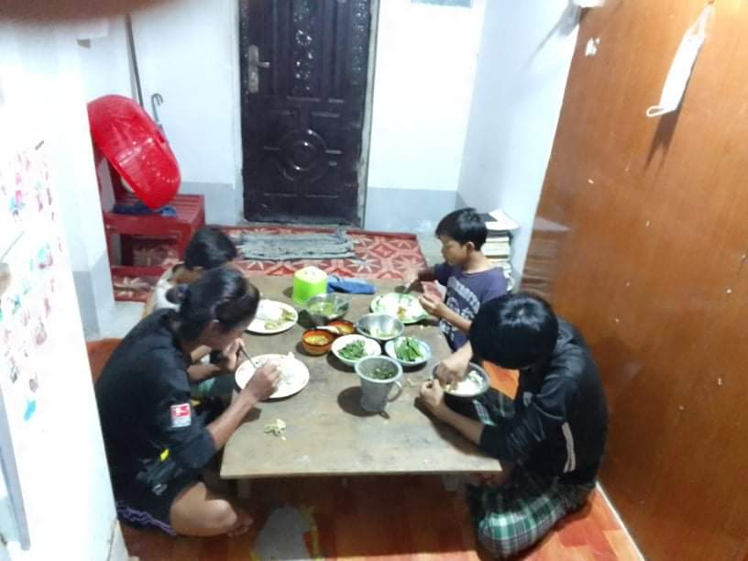****************************************************************************************************

#41 A report from Saya Htoo Htoo Wah, Lecturer in English at MIT.  
  
Dear Dr. Neil and Mrs. Diana Sowards and FOB Donors,  
  
I am writing to you again to express my heartfelt gratitude for your Christmas love gift for Thar Kyaw, whom I chose. Thar Kyaw, aged around 30, belongs to Myro ethnic group, a small ethnic group in Myanmar. He has been known to me for about ten years. He joined the liberal arts program of MIT for a bachelor degree in 2011 but he dropped out in his final year simply because of financial problems.  
  
Some years ago, he brought some Myro children from Rakhine State to Yangon and he looked after them. He rent a place, fed the children and sent them to school. He was able to do all these things mainly because of the financial support of his teachers and friends. At one point, the number of the children he looked after went up even to 15.  
  
Sometimes I visited them. But everything in Myanmar changed for worse when the military staged a coup in February, 2021. Talking only on economic situation, the living cost has become very high and it is very difficult for the poor to make both ends meet. The price of commodities doubles or triples. For instance, one liter of petrol before the coup was around 650 kyats, but now one liter of petrol costs around 1,450 kyats, Sadly so many people are living now simply on the handouts of the donors and well-wishers. Thar Kyaw is no exception. Not being able to look after his children anymore, he sent his children back home. I thought he is done with his Samaritan work.  
  
Fortunately or unfortunately, he is not. A few days ago, he wrote to me saying that now he is looking after four young boys and requesting me for help again. So, I gave him some donation and rice. In addition, Rev. Dr. Thomas Cung Bik, a good friend of mine, also gave him some rice and oil. And simply because of per kind favor of Dr. Thomas and his wife Dr. Fommen, I got a chance to give him your Christmas love gift (90,000 kyats).  
  
Thar Kyaw is very happy to receive your donation because it came at the right time. He admitted that he was really in need of money to buy some food for him and his children when he wrote to me.  
  
Right now they are staying at house. The rent is 125,000 kyats per month and one of his friends paid for a 3 month rent (They will have to renew the contract in April, 2022). At this moment, Thar Kyaw does not have a regular income. In order to earn some regular income, he is planning and praying for one computer and one printer (In Myanmar, there are some shops that offer printing and typing service) and Thar Kyaw wants to do this business. He loves writing and composing poems. He even has one book published.  
  
Again, thank you so very much for your love and care for Myanmar people. Things are really difficult and in some places, even dangerous. At a time like this, your love gifts really make a difference not only financially but also morally also because your love gifts make them remember that there are still some people who care about them.  
  
Thank you very much and may God continue to bless you all.  
  
Sincerely, Htoo Htoo Wah

#42 Dear Dr. Neil, Diana, and  FOB Donors,

I chose our pastor Zelma Tial Cin for the Christmas gift. Last year I asked her to give a Christmas gift to a needy person, and she did it and sent her report on it. This year I could not ask her because she herself has been taking chemotherapy and other medical treatment for her cancer. Yesterday my husband, my two children and I visited her and her parents (her mother is also suffering from cancer at this time). She was happy to receive the Christmas gift and encouraged by the concern and gift of FOB as she has been going through a lot. My husband prayed for her and her parents.

I would like to thank the donor of this Christmas gift. May God continue to bless you!

Sincerely, Fom Men

#43 A report from Rev. Dr. Thomas Cung Bik at MIT.

Dear Dr. Neil and Diana Sowards and FOB Donors,

Yesterday I gave one Christmas gift to Esther who is a widow and has a daughter. Her husband was an evangelist. When I was in the States, I heard that someone who fasted for 40 days passed away in Yangon. Last year I learned that it was her husband who died from fasting for 40 days. She has no one to support her. She could not find a regular job to earn a living for her and her daughter. She was in dire need. Last time when we spoke, her daughter was sick but she could not take her to any clinic or 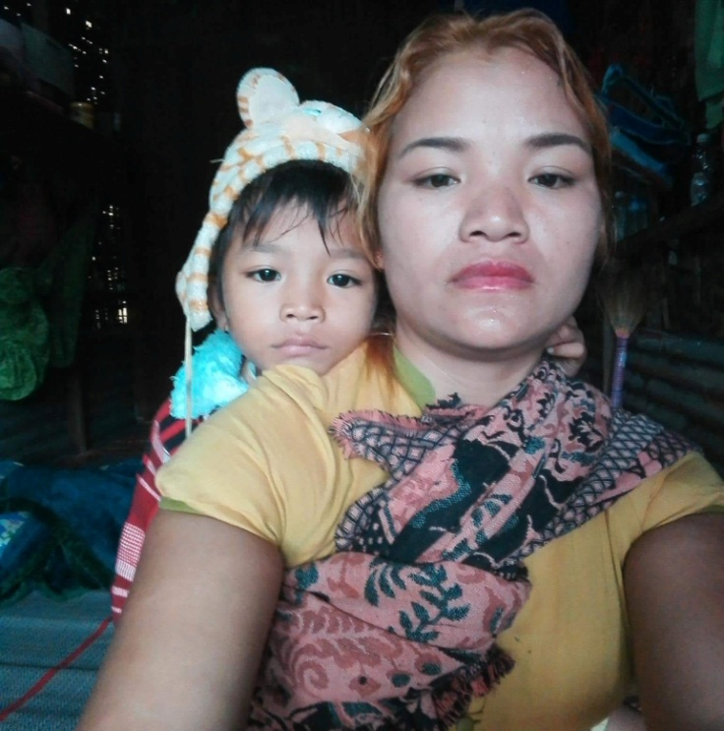hospital because she had no money. Since I could not go to their place, I sent some money to them. The other day, while I was thinking about this Christmas gift and whom I should give, I received a message from her. Since I helped her once before, she dared not ask me for money again. Instead, she asked whether she could borrow some money from me as she has been sick for a few days and could not work. I decided to give the Christmas gift of 90,000 kyats to her. I told her that my friend(s) in the US who care about the needy in Myanmar sent this Christmas gift to her. She praised God, thanked me and the donors for your gift. She asked me to convey her heartfelt gratitude to you and prayed that  God would bless you richly.

May God continue to bless you and make you a blessing to others in needy!

Shalom, Rev. Thomas Cung Bik, PhD, Coordinator of PhD Program, Myanmar Institute of Theology, Seminary Hill, Insein 11011. Yangon, Myanmar.

*************************************************************************************

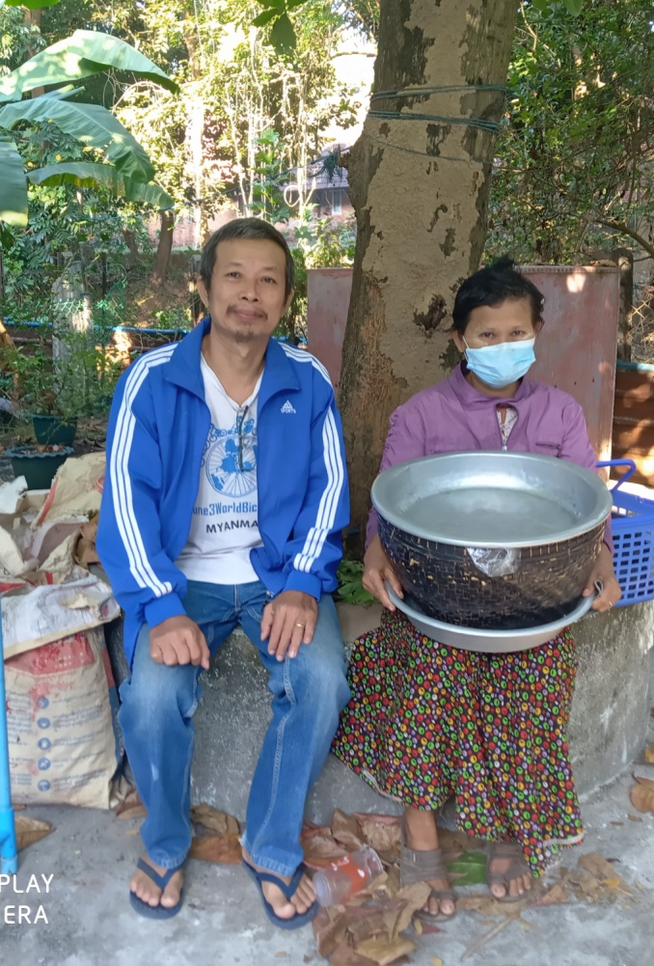 #44  report from Saya Klo Htoo, the Librarian at MIT.

Dear Dr. Neil and Mrs Diana Sowards and FOB Donors,  
  
The Christmas gift of 90000 kyats from Friends of Burma was given to  Daw Kyi Kyi who is a huckster. She has three family members, her mother is suffering paralysis and her daughter is studying in a nurse aid program.  She faces financial difficulties since she earns very little which is not enough even for the survival of her family. She earns about four thousand kyats a day, which can cover only for daily meals for them, but not for other expenses such as for health care, for clothing, for donation, etc.  For the extra expenses, she has to borrow from others who can lend her with mortgage rates. Actually she needs to get treatment for her eye but she does not have enough money for that.  When I gave the Christmas gift to her 90000 kyats, she told me to give only 50000 kyats to her because it was too much for her. So, I explained to her that the donation was not from me, but from Friends of Burma who love Myanmar people and want to help those who are in real need. When I gave the money to her hand, I saw the tears drop down from her eyes. She said, "Please say thank you to American friends." She was very happy to receive the gift and I also felt happy to see her happy with tears. The next day the whole of Myanmar did a silent strike. So, no one went outside to one open shop, no people and no cars on the roads. I also didn't know whether  she participated in the silent strike that day. She may not earn money for that day but I hope the Christmas gifts given to her meant a lot and brought real peace, joy and strength for her family this Christmas.  
  
Saw Klo Htoo

#45 & 46 A report from Rev. Mang Tungg Thang, Dean of LAP at MIT.  
  
Dear Dr. Neil and Mrs. Diana Sowards and FOB Donors,  
  
Happy New Year 2022. It is my pleasure to give you the Christmas Gift report. I have chosen the following two needy persons:  
  
**1. Mrs. Nuam Khan Huai (Insein, Yangon) Ks. 90,000**  
- I chose her because she appeared in my vision before I decided to give her the Christmas gift. She is struggling for her family while her husband is in Malaysia and unable to send money.  
- The financial situation of the recipient is so trifling. They don’t have any salary even though they are four family members during the covid-19 and coup.  
- The recipient cried on the phone when I told her to give this Christmas gift. She believed that it was God's arrangement for this year of crisis.  
- Friends of Myanmar (Burma) has the best job for those who are in extreme need. You really are a blessing to the needy people in Myanmar.  
  
**2. Mrs. Zam Ngaih Hau (Teklui village, Tiddim, Chin State) Ks. 90,000**  
- I chose her because she was struggling with her four children after her husband was killed in 2019.  
- The recipient does not have income and is from a poor rural family.  
- The recipient was exceedingly grateful because they never received such an amount of gift.  
- I also experienced that FOB has a good tradition of giving in the Christmas season as God gave His son.  
  
May God bless FOB richly to be able to help the needy continuously.  
  
In Christ,  
Saya Mang, Revd*Mang Tungg Thang,* Dean, Liberal Arts Program, Myanmar Institute of Theology, Seminary Hill, Insein

# 47, 48, 49, 50, 51 A report from Rev. Toe Toe Aye, General Secretary of Mon Baptist Convention.

Dear Dr. Neil and Diana Sowards and FOB Donors,

Thank you for your sharing Christmas gifts for five people in our area. I sent them to 5 people.

1) Pastor Saw Judson,Ye Mon Baptist Church who is unhealthy and low-income .

2) Pastor Myint Thein, Mudon Mon Baptist Church. He has a big family, he could share Christmas gifts with his family.

3) Pastor Nai Aung Gyi, Thanbyuzayat Mon Baptist Church. He could share with his church member who was poor.

4) Pastor Mi Aye Aye Khine, Singu Mon Baptist Church. She is poor-income.

5) Director Kya Bo, Mon Baptist Churches Union. He is poor-income.

With thanks,

Toe Toe Aye

**********************************************************************************

#52 Dear Dr. Neil and Mrs. Diana Sowards and FOB Donors,

I am writing a thank you letter for Christmas Gift. When I was informed about the program called “Christmas Gift” organized by Friend of Burma (FOB), I contacted some of my friends who pastored in Hakha. I got some information about a woman who was really in need. I met with her and asked her about her difficulties.

She has been struggling with chronic decease. Sometimes, because of her family situation, she could not take medication regularly. But she stays strong and prioritizes to her family members. She got a big family. Even though a big family, because of military coup and pandemic, they could not get certain job for regular income. For example, her husband is a carpenter but he has no job opportunity because they are living in conflict zone. When December comes, they have no idea about Christmas preparation like the past years. She and her family is really struggling with financial crisis for there is no way to get job for regular income. And, she herself has been struggling with chronic decease.

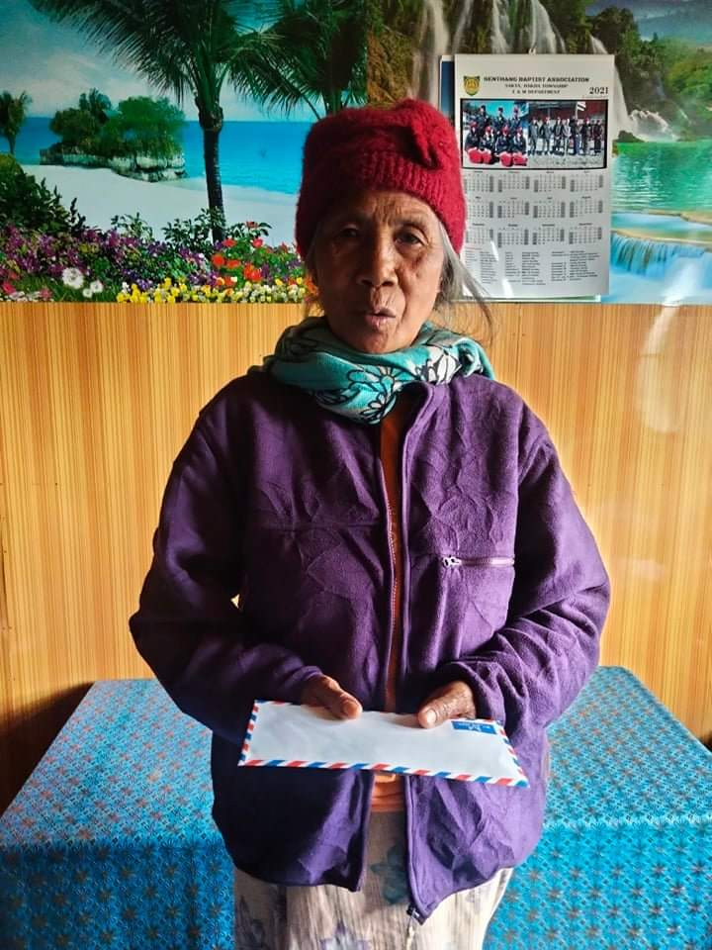When I gave her Christmas gift (90,000 MMK), she was really happy and talked about thank you words. Her face was shining and felt blessed. She said, “This is a precious blessing for me and my family. I am so happy because I can afford for medicine.” I was really inspired by her shinning face and happiness.

Finally, I would like to thank Dr. Neil and Mrs Diana Sowards (FOB) for your generous contribution called “Christmas Gift”. Your generous contribution is very helpful for the families who are in difficult times. May God continue to bless and use you all for the people who are in need.

Sincerely,

Pastor Abednego

******************************************************************************

#53 Report from Russ.

Dear Neil and Diana and FOB Donors,  
I think you know this girl. She is Su Pone Chit , a girl who got Christmas presents from FOB through Russ for many years continuously. She is nearly eleven years old. Her feature is changed and looks a little older. I use helf of the money to  bought some foods, drinks and cosmetics for her.  
I don’t want to give money because I don’t want the Gramdma will use the money for family expenses.  
The rest of the money went to her elder  sister, Khin Po Oo . I have  intended to give it to her since I didn’t receive the gift from Sayama Fom. When I went to her house she was not at home. She was sent to some where by her grandma. She is about 15 years old and friend of my girls from Bago Yoma.  
One day she asked Mr James Bond (our friend) to make a bad for her . She wanted to sleep together with her Grandma and younger sister together but her grandma told her to sleep alone because the bed is too small for three people. James Bond made a bad from some piece of wood and bamboo and put it near to her grandma’s bad.  
A few days later there was a news in the village that the girl was rapped by a man who is about 34 years.  
The girl was rape by that man several times. The man threatened to kill her if she told others. So she kept quiet, tried to sleep near her grandma. The mother of the girl was died by snake bite and the father is an alcoholic who never stay at home. After many inquiries the man said he will marry her but the the girl said instead of 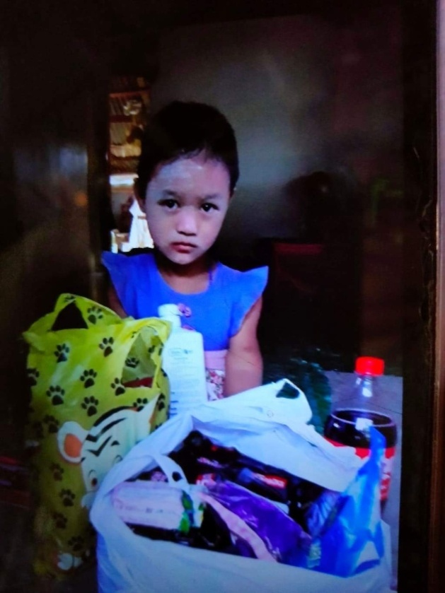marrying him she would kill herself.  
Actually the grandma knew everything since the beginning. She let it happened because she gave him favors. She has to rely on the man to help her in many ways. The anger of the villagers was on the Grandma. But the story is ended there.  
I gave a Bible with Hymns, a set of Karen dress, shampoo and soap for bathing for the girl through her Aunt. She doesn’t come to the village for long time. They are living outside of the village in the field. She doesn’t go to the school too.  
  
Thank FOB for giving me a chance to showing the love to the disable girl Su Pone Chit and her sister Khin Po Oo in Christmas time.  
Sincerely Tah Hso Gay

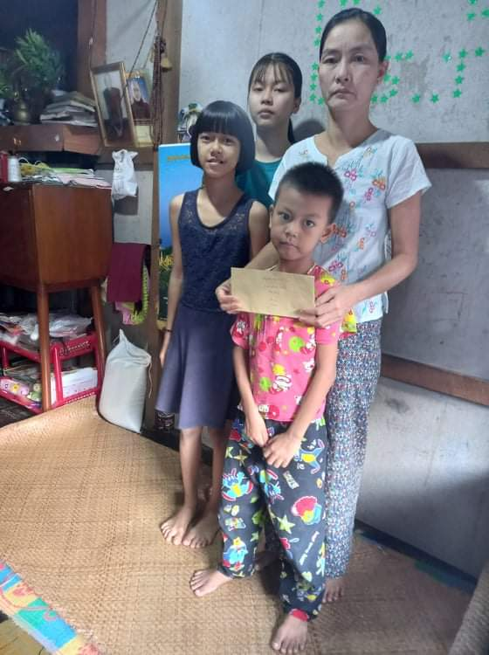#54 A report from Rev. Htet Lin Yin, a lecturer in Old Testament at Myanmar Institute of  Christian Theology.  
  
Dear Dr. Neil and Mrs Diana Sowards and FOB Donors,  
  
Daw Tin Tin Aye is a mother who has abandoned her husband and has to take care of three children. She earns her living by doing laundry at home. Due to the epidemic, she was not able to find a job in every household, so she had little income and was struggling for her family. So I gave her your Christian gift. She was very happy to receive it and grateful to you.  
     
Thank you so much for your donation. May God bless your organization more and more.  
  
Htet Lin Yin

****************************************************************************************************

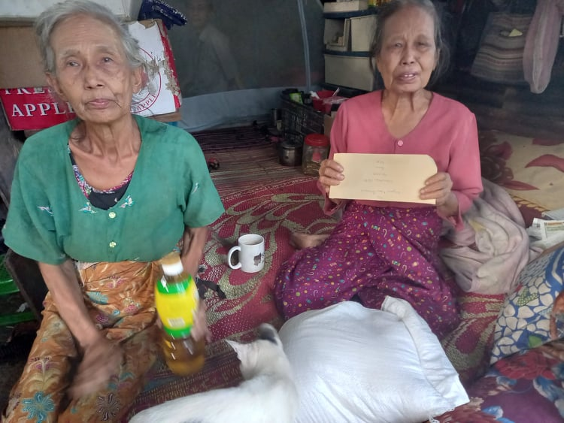#55 A report from Sayama Naw Patricia, a lecturer at Myanmar Institute of Christian Theology.  
  
Dear Dr. Neil and Mrs Diana Sowards and FOB Donors,  
  
Greetings from Myanmar! I gave your Christmas gift of 90,000 kyats to two widows (Daw Tin Aye, 75 and Daw Ohn Kyi, 77) who are sisters living not far from my school. They opened a homeless roadside noodle shop to earn a living. They hardly made enough for their family. I know them and that they are in dire need. They have no one to take care of them. So I chose them for the Christmas gift. They were very happy and thanked you for your Christian gift.  
  
Thank you very much for your support. May God bless you continually!  
  
Naw Patricia

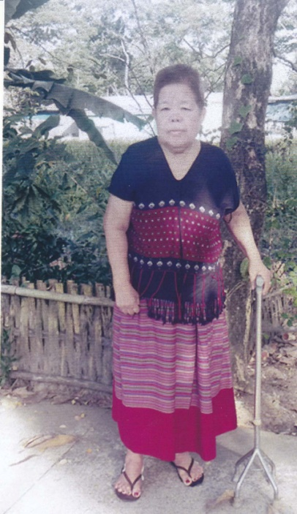#56 A report from Saya Nathanayla, Lecturer in Theology at MIT.  
  
Dear Dr. Neil and Mrs. Diana Sowards and FOB Donors,  
  
Greetings! I received a Christmas gift of Friends of Burma Kyats 90,000  for the needy from Rev. Dr. Thomas Cung Bik with thanks. I distributed this love gift at once to one of the needy families in  the church. The person who I gave is Naw Sreena who served as a deacon of the Philippi Karen Baptist Church for a long time. She got a stroke last 4 year ago and she was in bed for two years. By the grace of God, now she has recovered  and can move and walk in the house a little. When I reached her family and gave the love gift, she was so surprised and she thankfully received your Christmas' love gift.  
  
In her thanking letter (in Burmese, attached), she really thanked the donor so much for the generous Christmas love gift and may God continually bless the donor richly.  
  
She also asks to continue praying for her and family too. Now she stays living with her husband and her two orphan grandchildren.    
  
On behalf of her family, let me say thank you so much again and may God continue to bless the ministry of "Friends of Burma" richly.  
  
Blessings!  
  
Nathanayla, Lecturer, Department of Theology, Myanmar Institute of Theology.  
******************************************************************************

#57 & 58 A report from Dr. S' Joseph, Associate Professor at MIT.

Dear Dr. Neil and Mrs. Diana Sowards, and FOB Donors,

Happy New Year! Thank you very much for all your love and kindness towards us/our people.

The following is a brief report of the two recipients of the Christmas gift of FOB.

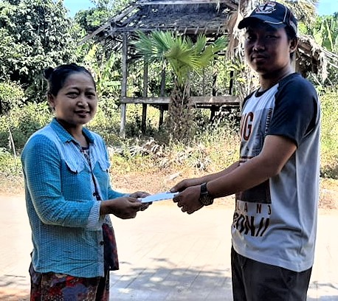**Naw Kler Si Paw (57 years) (Breast Cancer Patient) from Ahlone Township, Yangon Division**

1.      She used to come and ask for medical treatment from us because she has no money and would like to give up to take Chemotherapy. That’s why I chose to give her a Christmas gift.

2.      No family background and request to live at a Church compound. She always asks for basic food from us. She definitely needs financial assistance.

3.      She is so happy now and keeps her hope to fight against her CA. (Photo record)

4.      For me, I am happy because I could bring the Hope of Christmas to her at Christmas time.

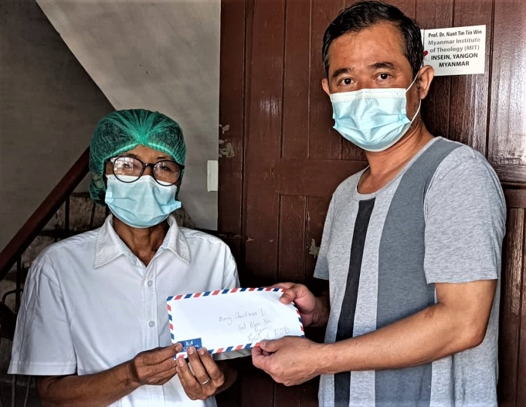**Naw Takabaw Poe (Kidney Failure) from Dawai Township, Taninsary Division**

1.      A church member requested me to find financial assistance for Naw Takabaw Poe who cannot afford weekly dialysis. She would also like to give up her weekly dialysis due to the shortage of money. That’s why I chose to give her a Christmas gift.

2.      The needed money for two times a week for dialysis is a heavy burden for her.

3.      She is so thankful for receiving a Christmas gift from FOB. She gave her testimony in the Video Clip.

4.      I haven’t seen her in person but according to her videotaped testimony, happy tears escaped from my eyes.

May God bless you all abundantly.  With Christ’s Love, Dr. S’ Joseph, Associate Professor, MIT

#59 & 60 A report from Dr. Nant Tin Tin Win, Associate Professor at MIT.

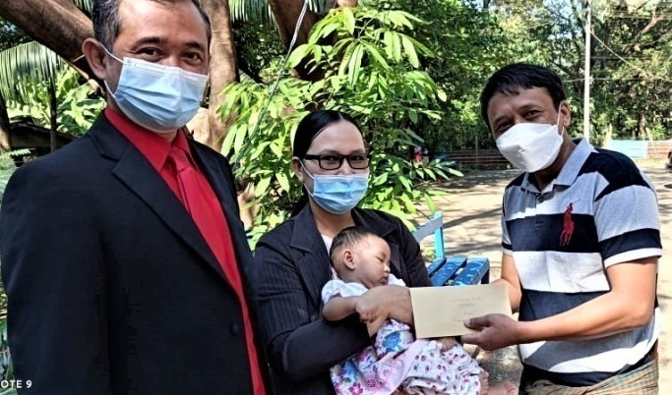Dear Dr. Neil and Mrs. Diana Sowards, and FOB Donors,

Happy New Year! Thank you very much for all your love and kindness towards us/our people.

The following is a brief report of the two recipients of the Christmas gift of FOB.

**Daw Myint Thein (65 years) – (Request to buy a prosthesis – artificial left-leg)**

1.      She lost her left-leg due to her heart disease. She would like to buy an artificial leg (left) – prosthesis, but she needs financial assistance. That’s why, I chose her to give a Christmas gift.

2.      An artificial leg – prosthesis is very expensive. She needs financial assistance.

3.      She is happy to receive a Christmas gift from FOB to walk back as before with the help of prosthesis.

4.      I feel myself as a messenger of God to her through FOB.

**Naw Hay Mu Khu Wah (6 months) – Cerebral Palsy (CP), From Pha-Pun Township, Karen State)**

1.      She is a very young patient who suffers from CP. Her mother is our MIT’s alumnus. (Her father is a farmer and her mother is a teacher from a seminary from Pha-Pun Township, Karen State.) Thus, I chose her and her family to be happy with a FOB’s Christmas gift.

2.      For a life-long treatment, her parents might definitely need financial assistance.

3.      Her mother, Thramu Naw Eh Wah (M. Th., - MIT) looks so relaxed and released from her current burden. She gives her heartfelt thanks to FOB through us.

4.      I pray that this young girl will be healed and become an instrument of God in the years to come.

 In Christ,

 Dr. Nant Tin Tin Win, Associate Professor, MIT

******************************************************************************

#61 & 62 A report from Sayama Mar Moora, Lecturer and Dean of Students of LAP at MIT.  
  
Dear Dr. Neil and Mrs. Diana Sowards, and FOB Donors,  
  
Greetings from Yangon, Myanmar and it was such a blessing to share the christmas gifts you have sent for the families in need. Last Christmas, Dr. Thomas Cung Bik and Dr. Fom Men gave me the two Christmas gifts from you, and I was able to present them to two families who are going through a tough time, struggling to have daily meals with their young children.  
  
The first family (Family 1) Saw Thet and Thida has two kids, a seven years old son and 18 months old daughter. Saw Thet has lost his job  since February and is trying to find and do odd jobs to make their ends meet throughout these months. The wife, Thida, also did cleaning and helping at the local Mont Hin Ga shop but the shop was closed due to current economic situations. Things are getting more difficult for them as it is difficult to find work and also they have two kids to feed and take care of. This family was chosen for this christmas gift as they are really in great need and the gift that they receive would help them to buy basic needs for their kids, especially for the 18 months old.  
  
The second family (Family 2), U Thein and Daw Aye, also has two kids, a 12 years old daughter and a two years old son. U Thein has hearing disability and has been working all the hard labor jobs to feed his family and Daw Aye goes around houses to do washing. Because of his hearing problems and the current situation, it is really challenging for U thein to earn money and their daughter has been out of school for two years already. Life is indeed an exhausting struggle for them but U thein always try to help around through labor works. This family was chosen for this Christmas gift as they are in great financial need  for survival as well as they have strong will to help people as much as they can even if they are in a very tight situation.  
  
Upon receiving christmas gifts, they were so surprised and happy as it came so unexpectedly for them. They can't hide their happiness and they are really grateful to everyone who made a channel of blessings for them.  
  
Being part of this process also made me reminded that life, indeed, is all about sharing love. Sharing love is really meaningful in the time of Christmas , especially to our youngest brothers and sisters in Christ. Moreover, it also made me realize that God made sure to reach out to His children in the most difficult time through other children. Whether it is Christmas or not, the sharing has to go on and we have to be the agent of God to touch lives around us to make them experience the Love of God through our kindness and sharings.  
  
Best,

Moora

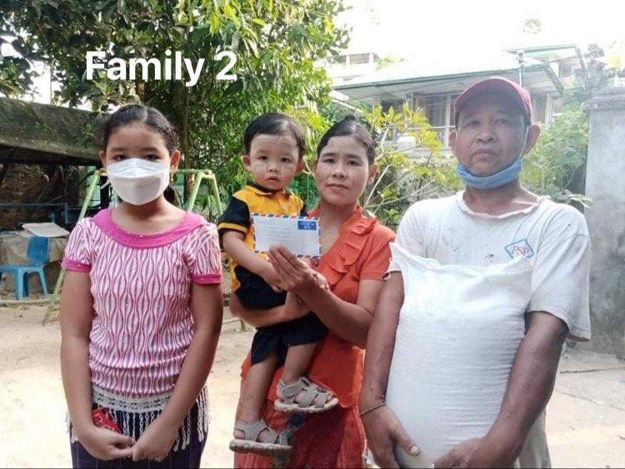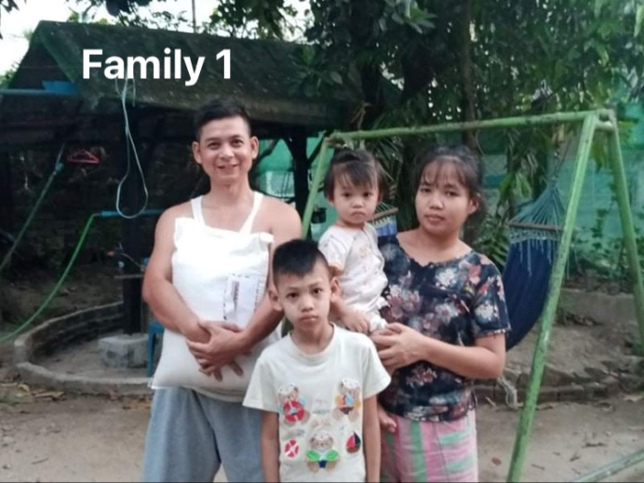

*************************************************************************************

# 63 A report from Rev. Dr. M. La Rip, Associate Professor and Dean of Students at MIT.  
Dear Dr. Neil and Mrs. Diana Sowards and FOB donors,  
  
Warmest Greetings from Myanmar! Thank you very much for your wonderful Christmas gifts that I could pass them to two people who really need help.  
  
1. How did you choose the recipient?  
I chose two women.  
The first one is an Indian washerwoman whose name is Binama. She is a widow with two sons. Her husband died in 2011 with high blood pressure. We live in the same ward in Insein. They are very poor.  
  
The second one whom I chose was a young Bama Christian minister. Her name is Thuza Win. She works in Hlaing Tharyar Township which is the most populated township in the country and many people are poor. She graduated from Myanmar Institute of Christian Theology. She works among Bama people. She is single. She actively works in her Church and in her community.  
  
2. What was the financial situation of the recipient?  
Binama had been working as a washerwoman throughout her life. However, due to the Covid-19 pandemic, she is not invited by people. She lost her job and has no income.  
  
Thuza Win is a full-time minister of Yangon Kachin Baptist Church. Her monthly salary is 140,000 Kyats which is equivalent to 79 USD at the current exchange rate. This amount is not enough for her ministry. She needs to visit her people by bus, by motorcycle, and by taxi sometimes. In addition, she may need to treat her people in organizing special events like the occasion of Christmas dance rehearsals. I had visited their small Church several times and I know the situation of this young minister.  
  
3. What was the reaction of the recipient?  
Binama was so surprised and was very happy when I called her phone. I did not go to her house because there were many people around her. So, I invited her to come to me and we met in front of our house due to the caution of the Covid-19 pandemic. I saw her joyful big smile on her face. She repeatedly said words of thanks to the donors.  
  
Thuza Win was also surprised and very happy to know that God remembers her through the love of the donors. She promised that she would be serving God as a servant throughout her life. She also prayed for the donors to be successful, prosperous, happy, healthy, protected, and to receive bountiful blessings from God.  
  
4. What was your experience?  
I was so happy literally to be a channel of blessings, distributing the wonderful Christmas gifts from FOB to the people who need help. I thank the donors of FOB because you have reached your hands to the people who need help. I pray for you all and ask you all to continue this good job in the future. May God bless you all! Actually, I have been helping FOB by assisting Saya Sweety and Dr. Fom Men for many years. At their requests, I transfer your humanitarian aids and scholarships to Kachin Baptist Convention and its theological schools. May God bless Dr. Neil and Mrs. Diana Sowards and FOB donors always!  
  
Warm Regards,  
  
Rev. La Rip Marip, PhD  
Associate Professor and Dean of Students  
Myanmar Institute of Theology, Seminary Hill, Insein, Yangon 11011, Myanmar

#63 Report of Peter Hrang Lian Thang

Dear Dr. Neil and Mrs. Diana Sowards and FOB Donors, I received your Christmas gift of 90,000 kyats on December 1, 2021 around 11:00 a.m. and gave it to Cungpi Pa who is in dire need. The photo was taken in my house when I gave your Christmas gift to him (he is the one without mask). He, his wife, and his two children came to stay at the IDPs camp at CCU where I am on the faculty. Even among the IDPs currently at CCU, in my opinion he is the most in need. I did not know him before he and his family came to the IDP camp. He is very poor and his children do not even have enough clothes, and the family is struggling to survive in this difficult time in our country. That is why I chose him to be the recipient of your Christmas gift. Before I gave him the Christmas gift, without telling him about it, I called him to my house. When I gave it to him, he was very surprised and also very happy to receive it when he was very much in need. I told him about your Christmas gift and he was very grateful to you for your concern and Christmas gift. He was very touched by his words of gratitude and prayers for you and even for me. I wish you could have seen his happy and smiling face when he received your gift. There are many needy families these days. I am very grateful for your thoughtfulness and this Christmas gift program for the least and the needy in Myanmar and for the opportunity to give your Christmas gift to Cungpi Pa. May our God continue to bless you and your ministry! Thank you very much!

Peter Hrang Lian Thang, Chin Christian University

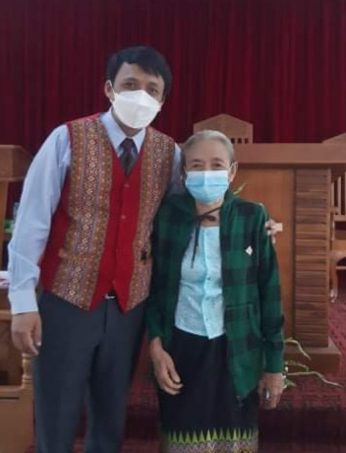#64 A report from Rev. Dr. Thomas Cung Bik at MIT.

Dear Dr. Neil and Mrs. Diana Sowards, and FOB Donors,

Last Sunday I had the opportunity to preach at Mizpah Baptist Church in North Dagon where my friend is a pastor. I brought one Christmas gift with me thinking that I might meet someone who is really in need. After the service I met with Mrs Mercy. She is suffering from back bone cancer. She has three sons and they do not have any job because of the current situation in Myanmar. One of her sons is suffering from depression. Her granddaughter has been receiving treatment due to a brain tumor. In such a difficult time, she was very happy to receive the Christmas gift of 90,000 kyats. I told her that the gift is from our Christian friends in the US who love us and always support the people in Myanmar. She asked me to thank you on her behalf and said that our God might bless you richly.

Thank you very much for your Christmas gift and for this opportunity to give it to Mrs. Mercy! May God continue to keep you, bless you, and use you more!

Shalom,

Thomas, Rev. Thomas Cung Bik, PhD, Coordinator of PhD Program, Myanmar Institute of Theology, Seminary Hill, Insein 11011, Yangon, Myanmar

#65  report from Rev. Dr. Thomas Cung Bik at MIT.

Dear Dr. Neil and Mrs Diana Sowards and FOB Donors,

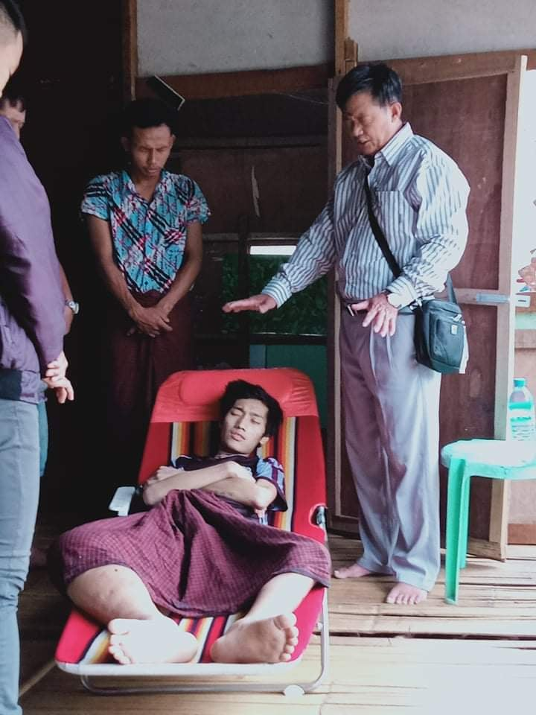On January 12 I saw a Facebook post by Pastor Khuanglang Jonah in Hlegu who asked for help for Sanai Jung Sar, a young man who has been suffering from bone cancer. The patient was first taken to Putao Hospital and then transferred to Myitkyina Hospital. The hospital in Myitkyina suggested his family take him to Yangon. With the help of the HOPE group who bought tickets for him and one family member to come to Yangon. According to the pastor, the patient is only 20 years old. Since they arrived in Yangon, he has been helping the family to be admitted to Yangon Hospital, and they had to wait in line for five days.

Since I could go there in person, I spoke with the pastor and told him about the Christmas gift from you. The pastor was very grateful for the gift since he has been trying to raise money to help this patient. After transferring the Christmas gift of 100,000 kyats to him for the patient, I told him to tell the patient that the Christmas gift is from FOB from the US and that we would keep him in our prayers.

Thank you very much for your Christmas gift!

Shalom,

Rev. Thomas Cung Bik, PhD, Coordinator of PhD Program, Myanmar Institute of Theology, Seminary Hill, Insein 11011, Yangon, Myanmar

#66 Report from Hser Nay Gay,

Dear Dr. Neil and Mrs. Diana Sowards and Friends of Burma (FOB)

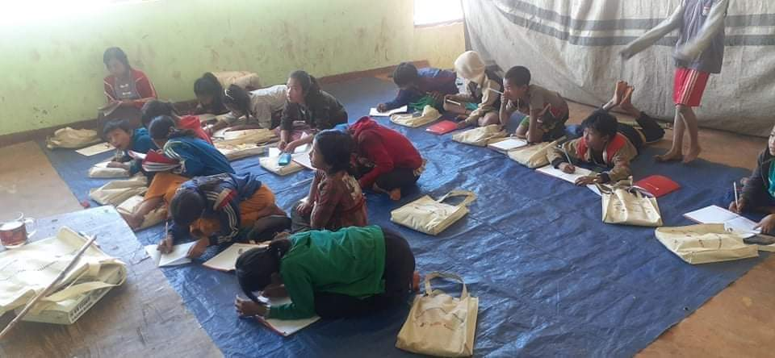Happy New Year!

I would like to give my heartfelt thanks to all of you for your “Christmas Gift” in December. I

chose one of my friends, Saw Hsaw Eh Htee Kaw (2018, MIT Alumni) from Kaya State. He had

been serving in the Orphanage. I believe that this special gift would make them happy in

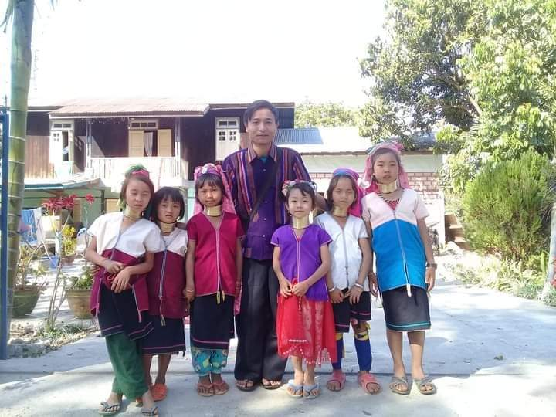Christmas time, as they had already planned to make a Christmas celebration. Due to the

unstable situation in our country, they became refugees as they have to hide in secure places.

When I saw they were suffering with loads of problems, I felt very sorry for them but on the

other hand, I am glad that we could show our love token by your “Christmas Gift.”

Thanks for your contribution.

Blessings!

Hser Nay Gay, (2018, MIT Alumni)

**#67, 68 & 69**

**1.The first one is Naw Thaw Thi Say who is 23 years old** and married and has two years old kid. Currently she is **suffering from blood deficiency** for 2 months. Her family came from Yakhing State and **live in displace people community** at LelGu. Her family lives with her parent's house and both her husband and she do not have regular income yet. When her health condition becomes under existing condition, she knows that she needs to go to hospital but they do not have enough money to go to hospital.

So both of them decided to take traditional treatment in their village and stay at home. When they feel hopeless to get money my field minister informs me about them.

Then the field minister calls her and she comes and meets her. Then I tell her about the Christmas gift from Neil and Diana and FOB donors and give her the Christmas gift. They are very happy and thank you so much for wonderful Christmas gift. The next day the couple goes to the public hospital and takes treatment from the hospital. After a week of hospitalization, she comes back to her home.

Now she is recovered and with her husband can go to their work site. She says this Christmas gift is very meaningful and precious for her life and also for the life of her family.

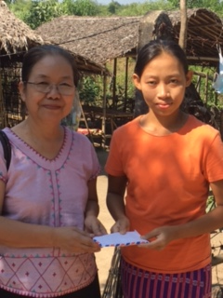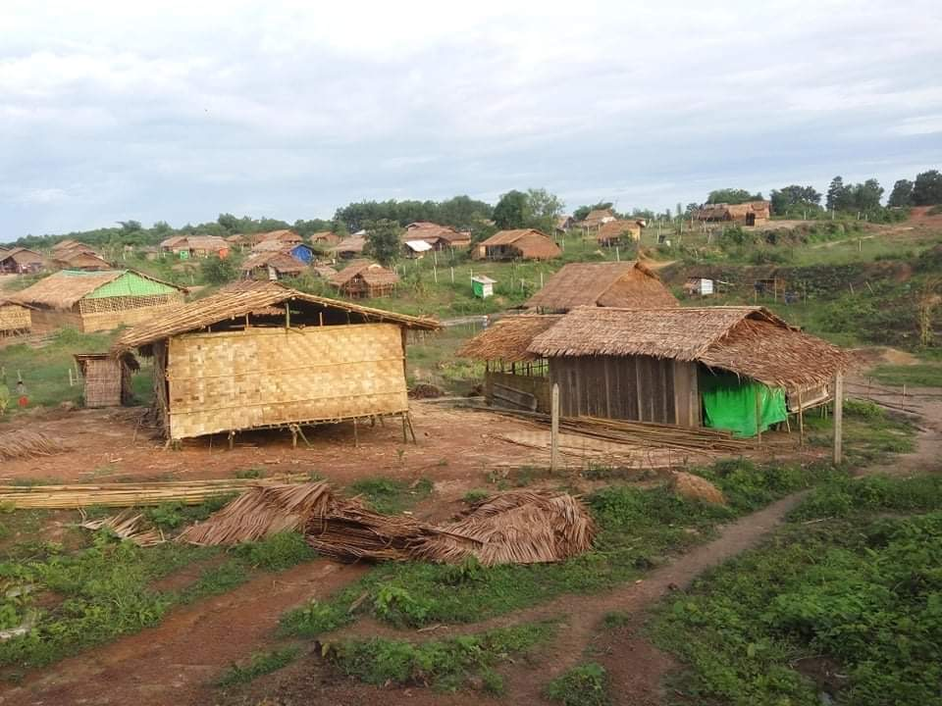

**2. The second one is given to Naw A Hge Ma , 32 years old** who lives in Thein Gone Village which is 3 hours driving far from Yangon. She is a single woman and **lives with her widowed mother and divorced sister with 2 kids**. She has supported her family since she was as teenager. She knows that she got **breast cancer** before she quit from her job.

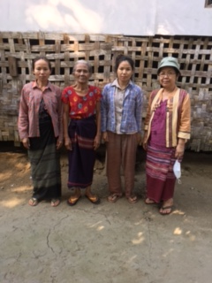As she worries about her family, she does not want to go to hospital because she has very limited cash to pay for expenses for the treatment. Her mother and sister could not support her financially. So she decided to take treatment from traditional healing methods and stay at home. Actually she feels very depressed and fear for her next stage of physical painful.

When I arrive at her house with her minister she feels very sad and her eyes are filled with tears. Then I talk to her and her family members, encourage them, pray for them and share with them about Christmas gifts and give your Christmas gift to her. She is very happy for very helpful Christmas gift because she does not have any income after she quit from her job. She requests me that to pass her thanks to Neil and Diana and FOB donors.

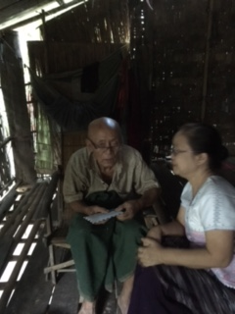**3. The third one receiver of Christmas gifts is Pu Pu Han Tin.81 years old** also lives in A Lel Hsu Village and is also a Bethlehem Karen Baptist Church member.He **lives alone** in his own house and his wife is cared for by his daughter.People who are surrounding of him provide him for daily meal.**His eyes sight and his hearing are getting weak** but he can walk and go down to ground floor everyday.

When I reach to his house with field minister, I talk with him for awhile about Christmas gift of Neil and Diana and give to him the gift. When he receives the Christmas gift,he raise his voice and say thank you repeatedly to the giver of Christmas gift. He is very happy and say thank you repeatedly because he rarely to receive the gift like this.He thank God and also to the giver. We also happy with him and thank God for this Christmas gift reach the right person in right time.

Reported by Naw Paw Gaw

#70

An evaluation of the Alternative Christmas Gift Program by a person who has the responsibility to give out some of the gifts in Burma.

Dear Neil & Diana,

Greetings from Zoe

How's Diana? Praying for her and also for you.

I want to apologize for my late **report on Christmas gift**.Now I'm busy with so many kinds of meetings in KBC, MBC and my own organization.As KBC Chair Person is passed away in Covid 19, I have to take this responsibility for the Chairperson of KBC.So I have extra work to do in KBC.But I'm happy and enjoy with my busy work.I know that even I'm not an expert one and skillful person,God use me and trust me and people also trust me to work with them.

 I have finished my self help group conference with MBC Women Department in November 2021.I will report it in next time.

God be with you all.

In His Service, Naw Paw Gaw

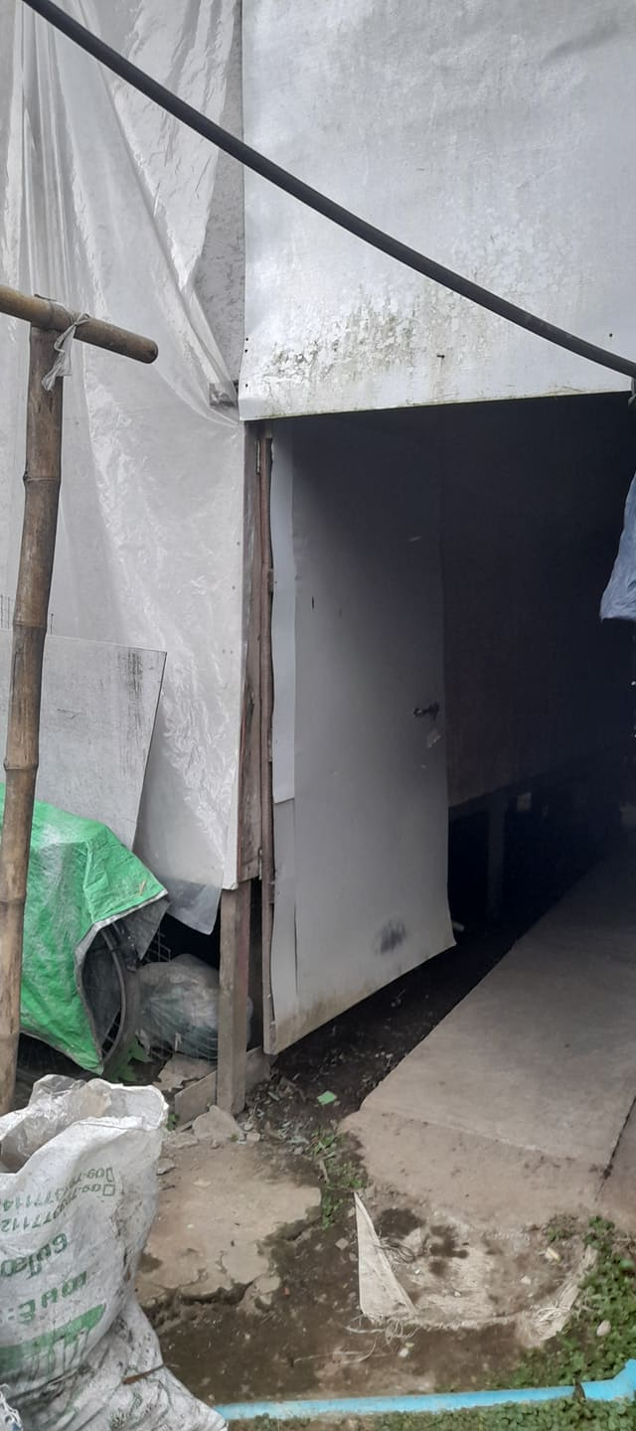#71  report from Rev. Dr. Thomas Cung Bik at MIT.

Dear Dr. Neil, Diana, and FOB Donors,

I was informed by a colleague that a Kachin family who lives not far from MIT is in need. My colleague and I visited the family and gave them your Christmas gift of 90,000. The husband was away to find a job when we visited them. The wife was there and very happy to receive the Christmas gift. This family used to open a small shop where students came and ate breakfast or dinner. Since the school besides their shop was closed due to COVID-19, they had to close it. Now they rent a small piece of land where they built a small house (more like a temporary hut). When it was raining, I was told the house was flooded by one-two feet of water, and it was difficult for them to live there. They are struggling to make ends meet.

I prayed for the family. The wife was very grateful and asked us to convey her heartfelt thanks to you. May God continue to bless you richly!

Shalom, Thomas, Rev. Thomas Cung Bik, PhD, Coordinator of PhD Program, Myanmar Institute of Theology, Seminary Hill, Insein 11011. Yangon, Myanmar

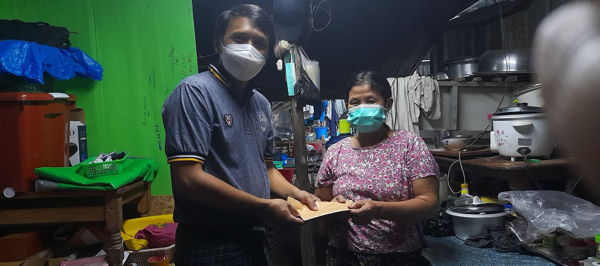

#72 A report from Rev. Moo Ler Gay.

Dear Rev. Dr. Neil and Diana and FOB Donors,

May the blessings of God be with you always. Thank you so much for your Christmas gift for the needy person. I bought some food and a blanket for them. Tha Wah and I worshiped with them and told them about gifts. .I gave it to two families. The first family is Saw Say Wah. He is 80 years old and he stays with his daughter's family. Saw Say Wah is playing the violin at Kothabyu Church and his daughter is a housemaid. The second family is Naw Mee Don 65 years old. Her husband died for many years and she has three children but last year her oldest daughter died. Now she lives with her daughter and son. Her daughter is in poor health so I have to give medical fees for her. As you know, this time is very difficult for the grassroot families in Myanmar. So when they get it, they are happy and thank those who gave them Christmas gifts. I would like to give you two pictures. The first is Saw Say Wah and his daughter and the next is Naw Mee Don.

With best regards, Moo Ler Gay, Pathein

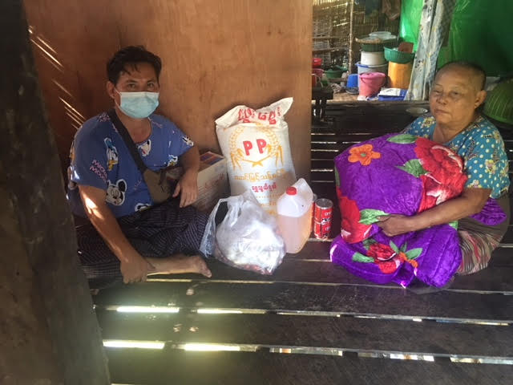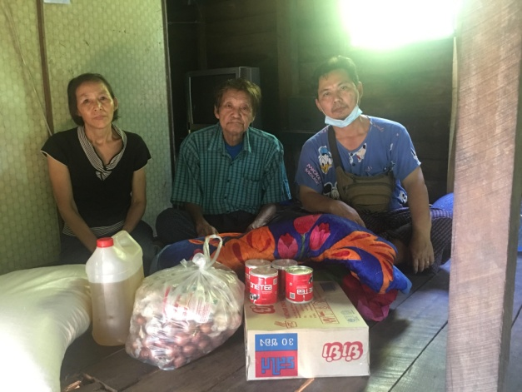

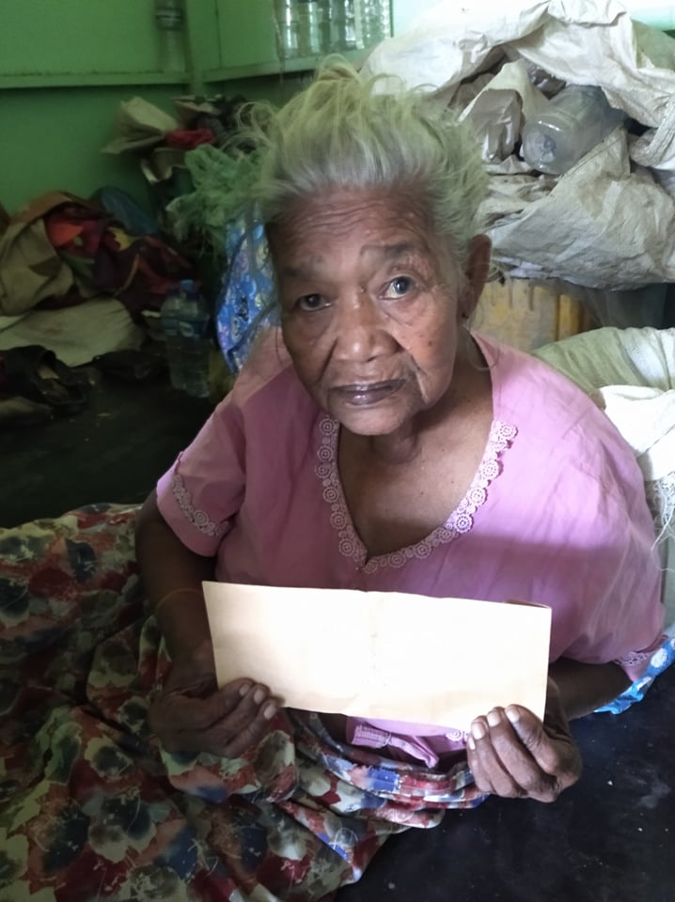#73, 74, 75. Dear Dr. Neil, Diana, and FOB Donors,

With the help of Pastor Chit Maung who is a pastor and missionary in Dala, we gave two Christmas gifts to three widows who are needy.

**Daw Khin Myint (90,000)**

Dawt Khin Myint is 95 years old. She has no children. She has no place to live. She slept beside other people's houses or shops and asked for food. When she was not sick, she asked a tricycle driver to help her. The tricycle driver was sorry for her and took her to his house. The tricycle driver has a wife and two daughters, and he himself is working hard to feed his family. He does not have a house, so he is renting a house. The tricycle driver and Daw Khin Myint were very happy to receive the Christmas gift when they were in this desperate situation.

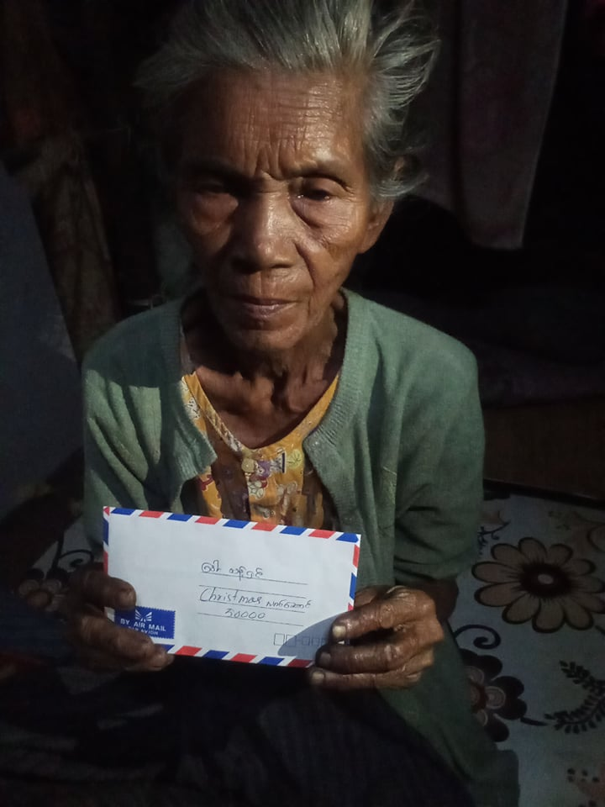

**Daw Thant Shin (50,000)**

Daw Thant Shin and her husband U Kyaw Myint Aung live with their three grandchildren. U Kyat Myint Aung is struggling to earn a living for his family by driving a tricycle. Since he is old, people do not want to ride in his tricycle. So, he can hardly make 2000-3000 per day. So they are in a very difficult situation. In this difficult time, the gift meant a lot to her family.

**Daw Myaing (40,000)**

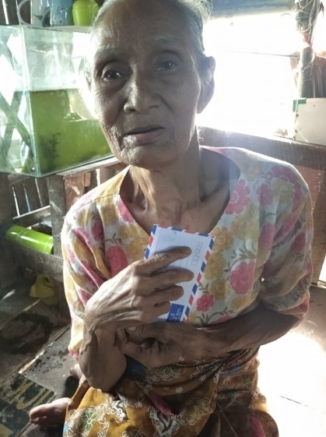Daw Myaing is 90 years old and lives with her daughter Daw Khin Nwet. Daw Khin Nwet's husband died of COVID-19. Now they both are widows. Daw Myaing has a son, but his son is also struggling to feed his family of seven and cannot help them. So they are in need of help.

Pastor Chit Maung told me that when they all received the Christmas gifts, they were very surprised and happy and thanked the donors for their love and concern.

Thank you very much for your Christmas gifts. Sincerely, Fom

#76 Dear Neil and Diana and FOB donors,

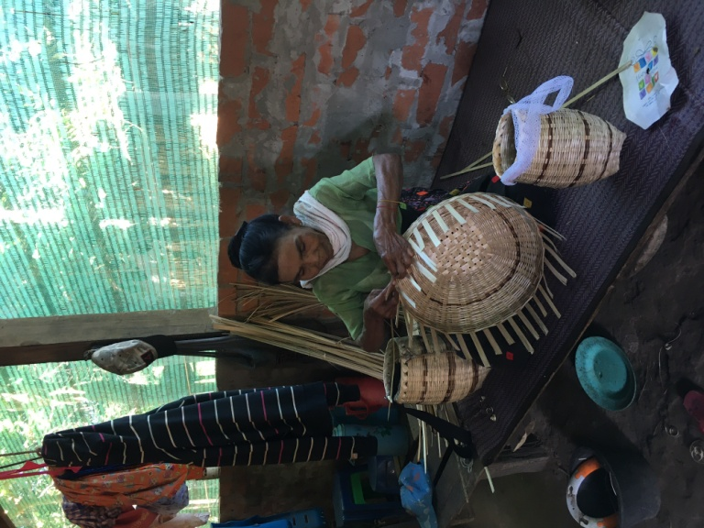I went there Teikkyi to clean my father house. At nearby house I found a lady named Daw San San Mya . She is a widow with three daughters and a son. Her son is not a good son . He takes no responsibility for the family. Two daughters got married and they have some kids. Her son-in-law goes in  to the jungle and cut the bamboo almost every day to earn money. She ask her son in law to bring her some bamboo to make bamboo basket.  
She is about 76 and trying to earn money by making many kinds of bamboo  baskets. I saw she raised some chicken too. She was survived from Covid-19 and now come back to work with her knife. She sells a small bamboo basket in 500 Kyat and 1000 Kyat for the big one. She said she can make up to three baskets a day. She can  make some others things like trays and buckets for fishermen.  
Her spirit of working touch me to give her 40000 Kyat. Without hesitation I did it. She was so happy and blessed the donor and me in the way Christian use to say. As the reaction of love I received a small bamboo basket as a present again.  
Thank you so much for sowing the seeds of love.  
Sincerely Russ

***************************************************

# 77 & 78. Dear Neil and Diana and FOB donors,

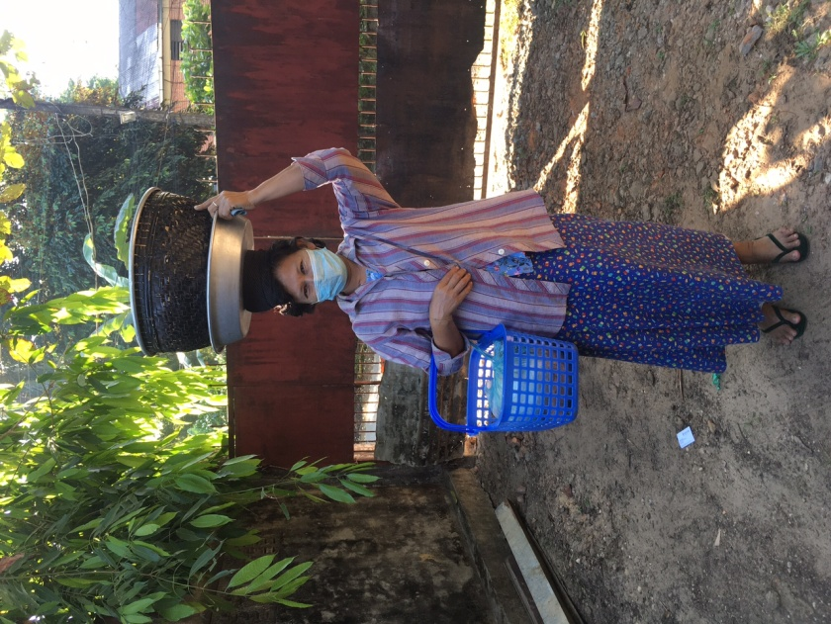  
Since last 30 years, every early morning about 6 am we hear the voice shouting “ Pae byout Naan Bya” on the street until now. A lady named Daw Tin Tin Hla , who is living far about 6 miles away from my house selling boiled beans and Naan bread is struggling for her family. Actually she got this job from her mother. Her mother earned for her family by selling that traditional breakfast since I was child.  Now she is nearly 80 and cannot work anymore.

Daw Tin Tin Hla has a daughter but she is unable to work except cooking for the family. Both of them are widows.

Daw Tin Tin Hla is saving money to get her eye surgery. But she said it never reached the target amount. I told her to come back to me after selling. About 7:30 she was back to me. I gave her 50000 Kyat a week before Christmas Day. She was so happy and said “thank you so much“ to the donor. And she said she will save the money for her eye surgery.

I think she doesn’t get the surgery until now because I hear her voice this morning.

Anyhow you have made her happy. She gave me two slices of Naans for the breakfast. I can feel the reaction of love.

Thank you so much for making people happy. Sincerely Russ

****************************************************************************************************

#79 Dear Dr. Neil, Diana, and FOB Donors,

I sent two Christmas gifts to a pastor in Monywa (a pastor of my mom and my siblings). He told me on the phone that he had given the gifts to a medical doctor and a university professor. Both of them stopped going to work and are now without income and in a difficult situation. The doctor has been treating patients for free, and without any income, he is in dire need.  
  
The pastor and his family are hiding because he has been helping IDPs and at this time it is not safe for his family to live in their own house.

Sincerely,  
  
Fom

#80 & 81 A report from Rev. Dr. Thomas Cung Bik.

Dear Dr. Neil and Mrs. Diana Sowards, and FOB Donors,

I would like to give a report on two Christmas gifts.

**A Patient in Hlegu**

This patient will undergo heart surgery soon. His parents are very poor. The family, I was told, is from Rakhine. They fled their village a few years ago due to the Rakhine crisis. Now they live in a village called Wet Inn Baut near Hlegu. One of their leaders called me and asked me whether I could find some help for the family in this difficult time. So, I decided to give the family a Christmas gift (90,000). I sent the money to them through a pastor (attached) who lives not far from them and who also knows the family.

**Mrs. Sun Tlem (N. Dagon)**

I have known Mrs. Sun Tlem for many years. When I was a youth leader in the early 1990s, she was very involved in youth activities. After many years, I met her again unexpectedly a few years ago. This time she told me that she is married and has two sons. But I am sad to learn that she is very poor. Her husband does not take care of the family. Sometimes she would come to me and ask me to help her. As much as I could, I helped her. But since COVID-19, I haven't seen her. Recently, I heard from my other friend that she is not feeling well and that her family is in dire need of food and medicines. So I decided to send her your Christmas gift of 90,000 kyats. At this time, it is not safe for me to go to her in person, so I sent her via wave money.

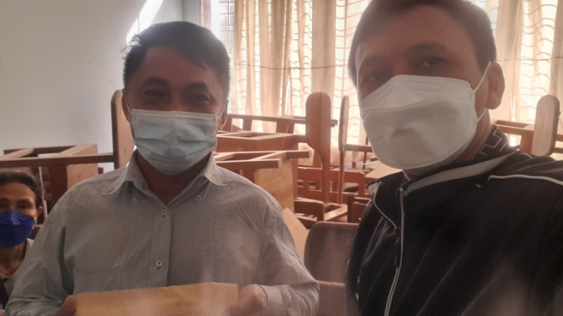They are very grateful for your Christmas gifts. They asked me to convey their gratitude to you.

Shalom, Rev. Thomas Cung Bik, PhD, Coordinator of PhD Program, Myanmar Institute of Theology, Seminary Hill, Insein 11011, Yangon, Myanmar

*************************************************************************************

#82 Dear Dr. Neil and Mrs. Diana Sowards and FOB donors.

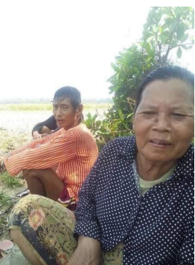 This letter is my heartfelt thank to you for Christmas Gift Sharing Program that I have received 90000 MMK for the needy as a second time. For this time, I chose a widow from ThaePhyuSu Village, Tarbaung Township, Pathein District of Ayeyawady Division.Her name is Naw Eh Htoo. She lost her husband who suffered a long battle with cancer in September,2021. As her children are away from her for work, she lives alone since her husband passed away. I transferred 90000 MMK gift to her through one of her sons who work in Myanmar Institute of Theology as a night guard security. By this Christmas gift, we can show our love and concern to her during such a tough time for her. After receiving the gift, she said thank to all the donors and now she can get some medical supplies for her as Covid 4th wave is widely spreading all over the country in Myanmar. Let me say thank you again for being a channel of blessing for people in need in Myanmar.

Best regards, Allen Soe Oo Property Supervisor Myanmar Institute of Theology

#83

Dear Neil and Diana Sowards and FOB donors,

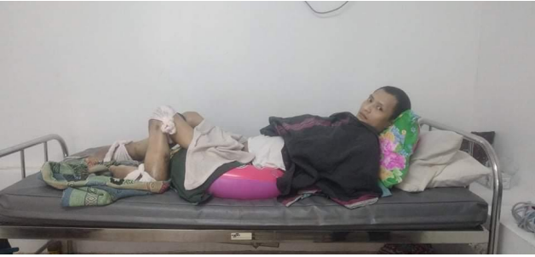 I am writing this letter to let you know about how much we thank you for Christmas Gift Sharing Program. One day in January, KBC Hospital announced that AB blood was urgently needed for a paraplegia patient to perform an operation and so I went and donated my blood. Before blood donation, I had a chance to talk with the patient. His name is Saw Eh Say Htoo from Tu Taw Lu village, Pathein township in Ayeyarwady Division. That 27 years old Karen boy have to cut off his two legs from knees because his legs are becoming and if not do so his life is threatening. That patient is from a poor family and can’t afford for hospital and operation fees. A pastor led and collected some money from donors and now he can get medical treatment at KBC Hospital. When I talk about that with Rev. Dr. Thomas Cung Bik and Dr. Fommen family, I have received 100000 MMK for the patient from Christmas Gift Sharing Program and at the next day, I went again to hospital and gave that amount to the patient. Let me say thank you again on behalf of the patient who is still at KBC Hospital and waiting for his operation.

Best regards, Allen Soe Oo Property Supervisor, Myanmar Institute of Theology

Photo: Saw Eh Say Htoo: Paraplegia patient with deformed legs from KBC Hospital.